**MOZILA FIRE FOX CLUB**

**EXTRA CURRICULAR COURSE**

**EXC1083- OPEN SOURCE INTERFACE**

**HOSPITAL MANAGEMENT SYSTEM**

**Final Review**

**NAME: V.TAMILSELVAN**

**REG NO: 21BCA0036**



**School of Information Technology and Engineering[SITE]**

**Table of Contents**

|  |  |  |
| --- | --- | --- |
| **CHAPTER NO.** | **TITLE** | **PAGE NO.** |
|  | **ABSTRACT** | vii |
|  | **LIST OF TABLES** | viii |
|  | **LIST OF FIGURES** | ix |
|  | **LIST OF SYMBOLS** | x |
| 1. | **INTRODUCTION** |  |
|  | 1.1 Motivation |  |
|  | 1.2 Issues |  |
| 2. | **PROBLEM DEFINITION** |  |
|  | 2.1 Critical Issues |  |
|  | 2.2 Problem Definition |  |
| 3 | **PROJECT DESCRIPTION** |  |
|  | 3.1 List of Modules |  |
|  | 3.2 Requirements Specification |  |
|  | 3.2.1 Software Requirements |  |
|  | 3.2.2 Hardware Requirements |  |
|  | 3.3 Module Description |  |
| 4 | **IMPLEMENTATION OF PROJECT** |  |
|  | 4.1. Source code |  |
|  | 4.2 Snapshot/Screen shots of the project |  |
| 5 | **RESULTS AND DISCUSSION** |  |
| 6 | **CONCLUSION AND FUTURE WORK** |  |
|  | **References** |  |

**ABSTRACT:**

The aim of our project was to build a responsive Hospital Management system.

Which includes “four modules patients , doctor, add card pharmacy, and labs.

The software has the facility to give a unique performance to book hospital lab tests done automatically. Even user can store there user name and password which can store the details next time you login without login to the site. In this we have used

Server site cookies which stores the user details into in. The data can be retrieved easily. The interface is very user-friendly. The data are well protected for personal use and makes the data processing very fast.

1. **INTRODUCTION**

This chapter starts with a high-level overview of the project. It then describes the specific aims and objectives of the project. Finally, it analyses the feasibility of the project and provides with a feasibility report of the system. Only they can add data into the database. The data can be retrieved easily. The interface is very user-friendly. The data are well protected for personal use and make the data processing very fast. Hospital Management System is powerful, flexible, and easy to use and is designed and developed to deliver real conceivable benefits to hospitals.

* 1. **Motivation:**

The real motivation for the hospital management system project is to make easy process of all the management process like patients infrastructure , doctors appointment, doctors prescription, etc. The user has to go through various registers. This results in wastage of time. So now by taking the motivation of this scenario which was regularly done in hospitals we are designing this system which can be benefited for the patients and there well wishing . So by this system it will become easy to manage all process.

* 1. **Issues:**

1.Privacy Issues. ...

2.Cybersecurity Threats.

3.Losing Data.

4.Payment Processing issues .

**2.PROBLEM DEFINITION:**

**2.1 Critical Issues:**

The information is very difficult to retrieve and to find particular information. The information generated by various transactions takes time and effort to be stored in the right place. This becomes a difficult task as information is difficult to collect from the various registers.

**2.2 Problem Definition:**

* Lack of immediate information storage: - The information generated by various transactions takes time to be stored at right place.
* Error prone manual calculation: - By manual calculations error can be occur and take a lot oftime this may result in incorrect information. For example calculation of patient’s bill based on various treatments.
* Preparation of accurate and prompt reports: - It is difficult task to collect information about patients from various register

**PROJECT DESCRIPTION**

**3.1 List of Modules:**

|  |
| --- |
| 1.pharmacy |
| 2.lab test |
| 3.patients |
| 4.doctor |

3.2 Requirements Specification

**3.2.1 Software Requirements:**

Design: HTML, CSS,javacript

Server site: apache local host

Application: visual studio code

**3.2.2 Hardware Requirements:**

Processor:Dual core processor

RAM: 1GB

Rom: SDD min 40GB

Internet connectivity.

Updated and proper supported browers.

With battery backup.

**3.3 Module Description**

**[i] Login page:**

This page is used to log in the user how log in before and they can save they user password and there information. Below this page we have many features like :

“Forgot password” => By this we can retrieve our older password , “sign in” => by this we can creare our own user and password by filling the details , finally we have included capcha it generate automatically the capcha.

**[ii]patient page:**

This page if fully dedicated for patient only to easy and comfortable to select there needs and what there need from our site. For there conveninen we have created the appointment in easiler manner 1.physical appointment 2.online appointment.In that they book there slot for doctor appointment.

**[iii]pharmacy**

In our pharmacy wish list cart we have each and every medicine. Even it rare medicine and dosage it will shipping to the patient to there address if they book via online. Every doctor prescripted medicine are available. And for every medicine definite discounts and cash back will be provided.

**[iv] doctors**

In our multispcialized hospital we have well experienced doctors and well trained doctors .our hospital is the ranked no.7th all over India certified by the government of India this because of doctors and staffs in hospital and they well take care of all patients

**[v]lab test:**

In our lab test we have builded many features like are list of medical tests and procedures used to obtain health information and diagnose pathological and nonpathological conditions of the human body. It is grouped by type of procedure and ordered alphabetically.

**IMPLEMENTATION OF PROJECT**

**4.1. Source code**

**Main page:[html]**

<html>

<head>

<title>Nova Multispeciality Hospital</title>

<link rel="shortcut icon" type="image" href="2.png">

<link rel="stylesheet" href="nova.css" type="text/css">

<link rel="stylesheet" href="new.css">

<link rel="stylesheet" href="https://cdnjs.cloudflare.com/ajax/libs/font-awesome/5.15.3/css/all.min.css"/>

<link rel="stylesheet" href="https://cdnjs.cloudflare.com/ajax/libs/font-awesome/4.7.0/css/font-awesome.css" />

</head>

<body>

<div class="title">

<a href="nova.html" target="_parent"><img src="2.png" class="img" /></a><b class="name">NOVA

<small><small><small>Multispeciality Hospital<sup>&reg;</sup></small></small></small></b>

</div>

<nav>

<ul class="f">

<li class="e"><a href="" class="g"><i class="fa fa-home"></i>Home<br></a></li>

<li class="e"><a href="appoinment.html" class="g"><i class="fa fa-book"></i>Book<br>Appointment</a></li>

<li class="e"><a href="error.html" class="g"><i class="fa fa-tablet" aria-hidden="true"></i> Buy<br>Medicine</a></li>

<li class="e"><a href="https://g.page/NovaIVFCHENNAI?share" class="g" target="_blank"> <i class="fa fa-location-arrow"></i>Hospital<br>Location</a></li>

<li class="e"><a href="error.html" class="g"><i class="fas fa-microscope"></i> LAB Result<br></a></li>

<li class="e"><a href="#contact" class="g"><i class="fa fa-phone" aria-hidden="true"></i> Contact Us<br></a></li>

<li class="e"><a href="#about" class="g">About Us<br></a></li>

<li class="h"><a href="load.html" class="g"><i class="fa fa-user"></i>&ensp;login</a></li>

</ul>

</nav><br>

<div class="main">

<marquee class="a" behavior="scroll" direction="left">

<ul class="b">

<li class="c">Nova multispeciality hospital is Frequently Recognised for its Commitment to Provididng World-class Healthcare & Excellent Patient Service</li>

<li class="c"><a href="#" class="d">50% offer in dialysis</a></li>

<li class="c"><a href="#" class="d">30% Disscount on OPD Test for a senior citizens</a></li>

</ul>

</marquee>

<img src="p1.jpg" width="100%" id="demo">

<div class="n">

<h1>chief Surgeon</h1>

<ul>

<div onmouseover="Cardiac()" onmouseout="amp1()">

<li class="doc" id="doc1"><img src="d.png" id="d1"/>

<h3>Dr. Naresh Trehan</h3>

<p>Cardiac Surgeon</p>

</li>

</div>

<div onmouseover="neuro()" onmouseout="amp2()">

<li class="doc" id="doc2"><img src="d.png" id="d2"/>

<h3>Dr. Bartolomeo Oliver</h3>

<p>neurosurgeon</p>

</li>

</div>

<div onmouseover="orthopedic()" onmouseout="amp3()">

<li class="doc" id="doc3" ><img src="d.png" id="d3"/>

<h3>Dr Bhushan Nariani</h3>

<p>orthopedic-surgeons</p>

</li>

</div>

<li class="but">

<button onclick="hap()">more...</button>

</li>

</ul>

</div>

<div class="m">

<div>

<h1>Why Choose<br>Nova Healthcare</h1>

<p>Established by <span>Dr hari haran</span> in 1983, NOVA Healthcare has a robust presence across the

healthcare ecosystem. From routine wellness & preventive health care to innovative life-saving

treatments and diagnostic services, Nova Hospitals has touched more than 120 million lives from over

120 countries, offering the best clinical outcomes.</p>

</div>

<img src="4.webp" />

</div>

<div id="about">

<div class="l">

<h1>Transplant Disclaimer</h1>

<img src="img1.jpg" />

<p>It has been brought to our notice that some people have received emails purporting to offer money for

kidney donation and misusing the name of Nova Hospitals. The public in general and kidney patients

in particular are hereby cautioned that these are fake phishing emails and that these mails are

neither sent by Nova Hospitals nor is Nova Hospitals involved in any such scheme. These fraudulent

and suspicious emails are only a scheme to extract payments from gullible individuals by misleading

them using the names of reputed hospitals. The Nova Hospitals transplant program is carried out in

accordance with</p>

</div>

<div class="l">

<h1>Recruitment Disclaimer</h1>

<img src="img2.jpg" />

<p>Nova Hospitals Enterprise Limited brings to your attention that persons not authorized by the Company

are circulating/posting fake advertisements inviting applications from candidates for employment in

the Company through e-mails and on leading job portals. Such advertisements demanding payments

through various online platforms and portals in exchange for appointments for interviews and offer

letters are fraudulent and the Company categorically states that it does not entertain such

practices in its recruitment process. We urge the public not to be misled by such communications

purportedly made by representatives</p>

</div>

<div class="l">

<h1>About lab </h1>

<img src="img3.jpg" width="500px" />

<p>The IVF clinic in Coimbatore is led by trained and experienced gynaecologists, infertility

specialists, andrologists, nurses, and embryologists and counsellors who work with empathy and

precision. Advanced experts at fertility clinics handle the most difficult of cases are pioneers in

setting IVF success rates.<br>Our doctors are backed ably by world-class infrastructure and highly

skilled embryologists who follow guidelines prescribed internationally such as ESHRE and also adhere

to ICMR guidelines. Our treatment plans are personalised for each patient to maximise their chances

of a positive pregnancy. In-house counselors offer personalised and continuous support throughout

the treatment process.</p>

</div>

</div>

<footer id="contact">

<div class="f1">

<div class="fp1">

<p class="pra1">follow us</p>

<div class="wrapper">

<div class="icon facebook">

<div class="tooltip">

Facebook

</div>

<span><a href="https://www.facebook.com/groups/1188241315442975" target="_blank"><i class="fab fa-facebook-f"></i></a></span>

</div>

<div class="icon twitter">

<div class="tooltip">

Twitter

</div>

<span><a href="https://twitter.com/"><i class="fab fa-twitter"></i></a></span>

</div>

<div class="icon instagram">

<div class="tooltip">

Instagram

</div>

<span><a href="https://www.instagram.com/"><i class="fab fa-instagram"></i></a></span>

</div>

<div class="icon whatsapp">

<div class="tooltip">

whatsapp

</div>

<span><a href="https://web.whatsapp.com/"><i class="fab fa-whatsapp"></i></a></span>

</div>

<div class="icon youtube">

<div class="tooltip">

YouTube

</div>

<span><a href="https://www.youtube.com/"><i class="fab fa-youtube"></i></a></span>

</div>

</div>

</div>

<div class="fp2">

<p class="pra1">Contact us</p>

<p class="pra2"><a href=""><i class="fa fa-phone"></i>Call:93421-99741</a></p>

<p class="pra2"><a href=""><i class="fa fa-newspaper-o"></i>mail:infantraj.s2021@vitsudnt.ac.in</a>

</p>

</div>

<div>

<p class="pra1">Download app</p>

<div class="d1">

<a href="https://www.google.com/aclk?sa=l&ai=DChcSEwiigobSoMT6AhWSmmYCHfpLCPEYABAAGgJzbQ&sig=AOD64_1sZQrX4vWdlvTD9v9EvV8iUcU29A&q&adurl&ved=2ahUKEwjaqP3RoMT6AhVxmeYKHeQEDlAQ0Qx6BAgEEAE"

target="_blank">

<div class="d2">

<i class="fa fa-android fa-2x"></i>

<div class="d3">

<p>Download from<br><span>Google play store</span></p>

</div>

</div>

</a>

<a href="https://www.google.com/aclk?sa=l&ai=DChcSEwiy2pThoMT6AhXwHHIKHQtcDgoYABAAGgJzZg&sig=AOD64_2LzTy9Vh-TILVn4v2tGvtuoQIjeA&q&adurl&ved=2ahUKEwjY-IzhoMT6AhWe0nMBHesYAPcQ0Qx6BAgEEAE"

target="_blank">

<div class="d2">

<i class="fa fa-apple fa-2x"></i>

<div class="d3">

<p>Download from<br><span>Apple store</span></p>

</div>

</div>

</a>

</div>

</div>

</div>

<div class="he1">

<p class="pra1">Overview</p>

<ul>

<li>&emsp;&emsp;<a herf="nova.html">Home</a></li>

<li>&emsp;&emsp;<a herf="#about">about</a></li>

<li>&emsp;&emsp;<a herf="">terms and use</a></li>

<li>&emsp;&emsp;<a herf="">faq</a></li>

<li>&emsp;&emsp;<a herf="">privacy policy</a></li>

<li>&emsp;&emsp;<a herf="">events</a></li>

<li>&emsp;&emsp;<a herf="">advisor</a></li>

</ul>

</div>

<div class="f3">

<div class="add">

<p class="pra1">address of hospital</p>

<address>

45/A,Datta Niwas,<br> Aarey Rd,Peru Baug,<br>

Mumbai,Maharashtra<br> India-401 105<br>

</address>

</div>

<div class="cop">

<p>Copyright &copy; 2022 Software Development Cell, NOVA, Mumbai-401 105.</p>

</div>

</div>

</footer>

</div>

<script>

var myVar = setInterval(function () { myslideshow() }, 10000);

var x = 0;

function myslideshow() {

var imgarr = ["p1.jpg", "p2.jpg", "p3.jpg", "p4.jpg"];

var obj = document.getElementById("demo");

if (x < 5) {

obj.src = imgarr[x];

x++;

if (x == 4) { x = 0; }

}

}

var mg=["d1.png","d2.png","d3.png"]

function Cardiac()

{

document.getElementById('d1').src=mg[0];

}

function neuro()

{

document.getElementById('d2').src=mg[1];

}

function orthopedic()

{

document.getElementById('d3').src=mg[2];

}

function amp1()

{

document.getElementById('d1').src="d.png";

}

function amp2()

{

document.getElementById('d2').src="d.png";

}

function amp3()

{

document.getElementById('d3').src="d.png";

}

function hap(){

document.location.href="error.html"

}

</script>

</body>

</html>

**Main page [css]**

body{

background-color: white;

margin: 0;

overflow-x: hidden;

}

.title{

background:url(3.jpg) no-repeat fixed center;

background-size: cover;

width: 100%;

}

nav{

width: 100%;

margin-top: 0;

height: 40px;

}

.img{

width: 55px;

height: 55px;

}

.name{

color: #ffff;

font-size: 45px;

}

.a{

background-color: yellow;

height: 45px;

width: 100%;

padding-top: 5px;

font-size: 20px;

}

ul{

list-style:circle;

margin-top: 0%;

padding-bottom: 2px;

}

.c{

color: red;

padding-top: 5px;

font-size: 20px;

cursor:wait;

}

li{

float: left;

padding-right: 30px;

margin-top: 0%;

}

.d{

display: inline;

text-decoration: none;

color: red;

}

.d:active{

color:blue;

}

.m{

background-color: gray;

display: flex;

justify-content: space-between;

padding: 40px;

border-top-left-radius: 50px;

width: 50%;

margin-left: auto;

margin-top: 5px;

}

.m span{

color: blue;

font-style:oblique;

font-weight: bold;

text-transform: uppercase;

}

.m img

{

height: 200px;

width:250px;

padding: 15px;

}

#about{

display: flex;

background: url(imgbg.jpg) no-repeat fixed center;

background-size:cover;

margin-bottom: 10px;

}

.l{

background-color: rgba(15, 10, 20, 0.514);

margin: 5px;

text-align: center;

margin-left: 74px;

}

.l img{

padding: 5px;

border-radius: 20px;

}

.l p{

width: 500px;

text-align: justify;

font-size: 1.3em;

color: #ffffff;

padding: 30px;

}

.f{

list-style:none;

width: 100%;

margin-top: 0%;

padding-bottom: 2px;

overflow: hidden;

background-color: black;

margin: 0%;

padding: 3px;

border-radius: 3px;

margin-bottom: 1px;

}

.e .h{

float: left;

padding-left: 5px;

margin-top: 0%;

border-right: 3px solid white;

padding-bottom: 4px;

}

.g{

display: inline-block;

text-decoration: none;

text-align: center;

color: white;

font-size: 12px;

padding: 10px;

padding-left: 20px;

padding-right: 20px;

font-family: Engravers MT;

border-right: 3px solid white;

border-radius: 15px;

}

.e{

padding-right: 30px;

}

.h{

float: right;

margin-top: 10px;

}

.g:hover{

border: 3px solid white;

}

.g:active{

background-color: gray;

}

#about{

margin-top: 10px;

background-color: honeydew;

}

.doc{

list-style: none;

display: inline;

padding: 25.3px;

margin-right: 20px;

box-shadow: 0 0 20px 2px rgba(0,0,0,0.4);

transition: 1s;

}

.n{

text-align: center;

background-color: peachpuff;

width: 90%;

height: 620px;

border-top-right-radius:100px;

}

.n img{

width: 300px;

height: 300px;

padding: 50px 75px 5px 65px;

}

.doc:hover{

transform: scale(1.2);

}

.but{

list-style: none;

}

.but button{

font-size: 25px;

margin-top: 470px;

margin-left: 100px;

box-shadow: 0 0 10px 2px rgba(0,0,0,0.4);

transform: scale(1.2);

}

.but button:hover{

box-shadow: 0 0 0 0;

transform: scale(1);

}

.but button:active{

box-shadow: 0 0 0 0;

transform: scale(1);

background-color: lightcoral;

color:aqua;

}

footer{

background-color: black;

width: 100%;

height: 600px;

display: flex;

}

.f1{

padding-top: 20px;

width: 33%;

border-right: 4px solid rgba(255, 255, 255, 0.085);

}

.fp1{

color: white;

}

.cu1{

display:flex;

justify-content: center;

}

.cli1{

list-style: none;

margin-right: 20px;

}

.cli1 a{

text-decoration: none;

display: inline-block;

color: white;

font-size: 30px;

padding: 8px 10px;

text-align: center;

border-radius: 60px;

}

.fp2{

color: #ffff;

}

.pra1{

font-weight: bold;

font-size: 30px;

color: #ffff;

text-decoration:4px underline rgb(240, 123, 143);

text-transform:uppercase;

}

.pra2 a{

text-decoration: none;

display: inline-block;

color: white;

font-size: 30px;

text-align: center;

margin-left: 40px;

}

.pra2 a:hover{

transform: scale(1.2);

text-decoration:3px underline;

}

.pra2 a:active{

color: cornflowerblue;

}

.d1{

color:white;

display: flex;

justify-content: center;

}

.d2{

display:flex;

padding: 15px;

margin-left: 40px;

border: 3px solid white;

}

.d2 i{

font-size: 30px;

padding: 20px 5px 0 0;

}

.d3 p{

font-size: 20px;

margin: 5px 2px 5px 2px;

}

.d3 span{

font-size: 30px;

}

.d1 a

{

color: white;

text-decoration: none;

}

.d1 a:hover{

transform: scale(1.2);

}

.d1 a:active

{

background-color: #ffff;

color: #000;

border: 3px solid rgb(0, 0, 0);

box-shadow: 0 0 20px 2px rgba(255, 255, 255, 0.4);

}

.d1 .d2 .fa-android:hover{

color: green;

}

.he1{

width: 33%;

padding-top: 20px;

border-right: 4px solid rgba(255, 255, 255, 0.085);

}

.he1 ul li{

list-style: none;

font-size: 20px;

text-transform:uppercase;

color: #ffff;

float: none;

padding: 10px;

cursor: pointer;

}

.he1 ul li a:hover{

text-decoration:3px underline lightseagreen;

}

.f3{

padding-top: 20px;

width: 33%;

}

.add{

border-bottom: 4px solid rgba(255, 255, 255, 0.085);

padding-left: 10px;

}

address{

color: #ffff;

font-size: 20px;

font-family: Arial;

}

.cop p{

color:#ffff;

font-size: 30px;

padding-top:50px;

}

=============================================================

[II] MAIN PAGE FOOTER.CSS:

@import url('https://fonts.googleapis.com/css?family=Poppins:400,500,600,700&display=swap');

.wrapper{

margin-top: 40px;

display: inline-flex;

}

.wrapper .icon{

margin: 0 20px;

text-align: center;

cursor: pointer;

display: flex;

align-items: center;

justify-content: center;

flex-direction: column;

position: relative;

z-index: 2;

transition: 0.4s cubic-bezier(0.68, -0.55, 0.265, 1.55);

font-family: 'Poppins', sans-serif;

}

.wrapper .icon span{

display: block;

height: 60px;

width: 60px;

background: #fff;

border-radius: 50%;

position: relative;

z-index: 2;

box-shadow: 0px 10px 10px rgba(0,0,0,0.1);

transition: 0.4s cubic-bezier(0.68, -0.55, 0.265, 1.55);

font-family: 'Poppins', sans-serif;

}

.wrapper .icon span i{

line-height: 60px;

font-size: 25px;

color: #000;

}

.wrapper .icon .tooltip{

position: absolute;

top: 0;

z-index: 1;

background: #fff;

color: #fff;

font-family: 'Poppins', sans-serif;

padding: 10px 18px;

font-size:20px;

font-weight: 500;

border-radius: 25px;

opacity: 0;

pointer-events: none;

box-shadow: 0px 10px 10px rgba(0,0,0,0.1);

transition: 0.4s cubic-bezier(0.68, -0.55, 0.265, 1.55);

font-family: 'Poppins', sans-serif;

}

.wrapper .icon:hover .tooltip{

top: -70px;

opacity: 1;

pointer-events: auto;

}

.icon .tooltip:before{

position: absolute;

content: " ";

height: 15px;

color: #000;

width: 15px;

background: #fff;

left: 50%;

bottom: -6px;

transform: translateX(-50%) rotate(45deg);

transition: 0.4s cubic-bezier(0.68, -0.55, 0.265, 1.55);

font-family: 'Poppins', sans-serif;

}

.wrapper .icon:hover span{

color: #fff;

}

.wrapper .icon:hover span,

.wrapper .icon:hover .tooltip{

text-shadow: 0px -1px 0px rgba(0,0,0,0.4);

}

.wrapper .facebook:hover span,

.wrapper .facebook:hover .tooltip,

.wrapper .facebook:hover .tooltip:before{

background: #3B5999;

}

.wrapper .twitter:hover span,

.wrapper .twitter:hover .tooltip,

.wrapper .twitter:hover .tooltip:before{

background: #46C1F6;

}

.wrapper .instagram:hover span,

.wrapper .instagram:hover .tooltip,

.wrapper .instagram:hover .tooltip:before{

background: #e1306c;

}

.wrapper .whatsapp:hover span,

.wrapper .whatsapp:hover .tooltip,

.wrapper .whatsapp:hover .tooltip:before{

background: rgb(0, 241, 36);

}

.wrapper .youtube:hover span,

.wrapper .youtube:hover .tooltip,

.wrapper .youtube:hover .tooltip:before{

background: #DE463B;

}

=============================================================

LOGIN [HTML]

<!DOCTYPE html>

<html lang="en">

<head>

<link rel="shortcut icon" type="image" href="2.png">

<link rel="stylesheet" href="login.css" type="text/css">

<link rel="stylesheet" href="https://cdnjs.cloudflare.com/ajax/libs/font-awesome/4.7.0/css/font-awesome.css" />

<script src="login.js"></script>

<title>Nova Multispeciality Hospital-login</title>

<style>

.h{

right: 0;

margin-top: 1px;

}

</style>

</head>

<body onload="cap()">

<div class="bg">

</div>

<div class="form">

<h1>Login</h1>

<form id="for" method="get">

<label for="us" >Username</label><br>

<i class="fa fa-user" id="user"></i>

<input type="text" name="username" id="us" placeholder="Username" ><br>

<label for="pass">Password</label><br>

<i class="fa fa-lock" id="lock"></i>

<input type="password" name="password" id="pass" placeholder="Password"><br>

<label for="capcha">Enter capcha</label><br>

<input type="text" readonly id="capt"><input type="text"id="capcha"><br>

<input type="button" id="submit" value="Login" onclick="loginval()">

</form>

<p class="c1">Capcha is not visiabla<img src="refresh.png" onclick="cap()" width="40px"></p>

<p class="p1"><a href="forgot.htm" class="a1">forgot Password</a>New User</p>

<p class="p2"><a href="register.html" class="a3"><i class="fa fa-sign-in" aria-hidden="true"></i>Sign in</a></p>

<p class="p2"><a href="nova.html" class="a1"><i class="fa fa-backward" aria-hidden="true"></i> Back</a></p>

</div>

</body>

</html>

=============================================================

LOGIN [CSS]:

body{

overflow: hidden;

margin: 0;

}

.bg{

height: 1900px;

background:url(loginbg.jpg) no-repeat fixed center;

background-size: cover;

filter: blur(7px);

z-index: -1;

}

.form h1{

text-decoration: underline;

text-align: center;

margin-top: 10px;

}

.form{

background-color: rgba(0, 0, 0, 0.847);

z-index: 2;

position: absolute;

top: 100px;

color: white;

width: 30%;

left: 650px;

font-size: 25px;

padding: 30px;

box-shadow: 10px 10px 10px 2px rgb(46, 46, 46);

}

#us,#pass{

width: 340px;

font-size: 25px;

margin-left: 130px;

margin-bottom: 20px;

padding-left:20px ;

}

label{

margin-left: 120px;

padding: 10px;

cursor: pointer;

}

#capt{

height: 30px;

width: 150px;

margin-left: 120px;

font-size: 20px;

}

#capcha{

height: 30px;

width: 150px;

margin-left: 50px;

font-size: 20px;

}

#submit{

font-size: 25px;

margin-top: 20px;

margin-left: 250px;

padding: 10px;

}

.p1{

margin-bottom: 0;

padding-bottom: 0;

}

.p2{

padding-top: 0;

margin-top:0;

margin-bottom: 0;

padding-bottom: 0;

}

.a1{

margin-right: 340px;

}

.a3{

margin-left: 30px;

}

.a1,.a3{

color: white;

text-decoration: none;

}

.a1:hover{

text-decoration: underline solid white;

}

#user,#lock{

position: absolute;

left: 160px;

color: rgb(255, 255, 255);

padding-top: 4px;

}

input{

background-color: transparent;

border: none;

border-bottom:2px solid white;

color: white;

}

input[type="button"]

{

background-color:black;

color: white;

border-radius: 50%;

}

#capt{

background: url(cb.jpg) no-repeat fixed center;

background-size: cover;

color: wheat;

letter-spacing: 10px;

}

#capcha{

border: 2px solid white;

color: white;

}

.a3{

margin-left: 500px;

}

=============================================================

**LOGIN [JS]**

function cap() {

var alpha = ['A', 'B', 'C', 'D', 'E', 'F', 'G', 'H', 'I', 'J', 'K', 'L', 'M', 'N', 'O', 'P', 'Q', 'R', 'S', 'T', 'U', 'V', 'W', 'X', 'Y', 'Z', '1', '2', '3', '4', '5', '6', '7', '8', '9', '0', 'a', 'b', 'c', 'd', 'e', 'f', 'g', 'h', 'i', 'j', 'k', 'l', 'm', 'n', 'o', 'p', 'q', 'r', 's', 't', 'u', 'v', 'w', 'x', 'y', 'z', '!', '@', '#', '$', '%', '^', '&', '*', '+'];

var a = alpha[Math.floor(Math.random() * 71)];

var b = alpha[Math.floor(Math.random() * 71)];

var c = alpha[Math.floor(Math.random() * 71)];

var d = alpha[Math.floor(Math.random() * 71)];

var e = alpha[Math.floor(Math.random() * 71)];

var f = alpha[Math.floor(Math.random() * 71)];

var final = a + b + c + d + e + f;

document.getElementById("capt").value = final;

}

var a1 = 0, b1 = 0, c1 = 0, d1 = 0, e1 = 0, f1 = 0;

function formValidation() {

var frm;

var uid;

var passid;

var cpassid;

var uname;

var uadd;

var uadd1;

var ucountry;

var uzip;

var uemail;

var ugender;

frm = document.getElementById("registration");

uid = document.getElementById("userid");

passid = document.getElementById("passid");

cpassid = document.getElementById("cpassid");

uname = document.getElementById("username");

uadd = document.getElementById("paddress1");

uadd1 = document.getElementById("paddress2");

ucountry = document.getElementById("country");

uzip = document.getElementById("zip");

uemail = document.getElementById("email");

ugender = document.getElementsByName("gender");

if (userid_validation(uid, 5, 12)) {

if (passid_validation(passid, cpassid, 7, 12)) {

if (allLetter(uname)) {

if (countryselect(ucountry)) {

if (allnumeric(uzip)) {

if (ValidateEmail(uemail)) {

if (validgender(ugender)) {

window.location.href = "login.html";

}

}

}

}

}

}

}

}

function userid_validation(uid, mx, my) {

var l = /^[a-z]+$/;

var uid_len = uid.value.length;

if (uid_len == 0) {

alert("User Id should not be empty");

uid.focus();

return false;

}

else if (uid_len >= my || uid_len < mx) {

alert("The length be between " + mx + " to " + my);

uid.focus();

return false;

}

else if (!uid.value.match(l)) {

alert("All should be alphabet");

uid.focus();

return false;

}

return true;

}

function passid_validation(passid, cpassid, mx, my) {

var passid_len = passid.value.length;

var cpassid_len = cpassid.value.length;

if (passid_len == 0) {

alert("Password should not be empty ");

passid.focus();

return false;

}

else if (passid_len >= my || passid_len < mx) {

alert("password length should be between " + mx + " to " + my);

passid.focus();

return false;

}

if (cpassid_len == 0) {

alert("conform Password should not be empty");

passid.focus();

return false;

}

if (cpassid_len >= my || cpassid_len < mx) {

alert("conform Password length should be between " + mx + " to " + my);

passid.focus();

return false;

}

if (cpassid.value != passid.value) {

alert("password and conform Password should be same");

passid.focus();

return false;

}

console.log(passid.value);

console.log(cpassid.value);

return true;

}

function allLetter(uname) {

var letters = /^[A-Za-z]+$/;

if (uname.value == null) {

alert('Username should not be empty');

}

else if (uname.value.match(letters)) {

console.log(uname.value);

return true;

}

else {

alert('Username must have alphabet characters only');

uname.value = "";

uname.focus();

return false;

}

}

function countryselect(ucountry) {

if (ucountry.value == "Default") {

alert('Select your country from the list');

ucountry.focus();

return false;

}

else {

console.log(ucountry.value);

return true;

}

}

function allnumeric(uzip) {

var numbers = /^[0-9]+$/;

if (uzip.value.match(numbers)) {

console.log(uzip.value);

return true;

}

else {

alert('ZIP code must have numeric characters only');

uzip.focus();

return false;

}

}

function ValidateEmail(uemail) {

var mailformat = /^([a-zA-Z0-9_\.\-])+\@(([a-zA-Z0-9\-])+\.)+([a-zA-Z0-9]{2,4})+$/;

if (uemail.value.match(mailformat)) {

console.log(uemail.value);

return true;

}

else {

alert("You have entered an invalid email address!");

uemail.focus();

return false;

}

}

function validgender(ugender) {

var isChecked = false;

for (var i = 0; i < ugender.length; i++) {

if (ugender[i].checked) {

console.log(ugender.value);

isChecked = true; // found one element checked

break;

}

}

if (isChecked == false) {

alert("Select male/female");

}

return isChecked;

}

function copy(form) {

form.taddress1.value = form.paddress1.value;

form.taddress2.value = form.paddress2.value;

}

function res() {

frm.reset();

}

/* luser.addEventListener("keyup", (e)=>{

var v=e.currentTarget.value;

lpass.disabled=false;

if(v==="")

{

lpass.disabled=true;

}

});

lpass.addEventListener("keyup", (e)=>{

var v=e.currentTarget.value;

lpass.disabled=false;

if(v==="")

{

ccap.disabled=true;

}

});

ccap.addEventListener("keyup", (e)=>{

var v=e.currentTarget.value;

if(v==="")

{

submit.disabled=true;

}

});*/

function loginval() {

var lfor = document.getElementById("for");

var luser = document.getElementById("us");

var lpass = document.getElementById("pass");

var cap = document.getElementById("capt");

var ccap = document.getElementById("capcha");

if (capcha(cap, ccap)) {

if (loginuser(luser, lpass)) {

cookievalue = escape(document.getElementById("us").value) + ";";

document.cookie = "name=" + cookievalue;

var now = new Date();

now.setMonth(now.getMonth() + 1);

document.cookie = "expires=" + now.toUTCString() + ";"

console.log("successfully login");

lo();

}

}

}

function lo() {

window.location.href = "nova main.html";

}

function loginuser(a, b) {

var username = ["infant", "hari", "karthi"];

var password = ["21bca0104", "21bca0100", "21bca0089"];

for (var c = 0; c < username.length; c++) {

if (a.value == username[c]) {

if (b.value == password[c]) {

return true;

}

}

}

alert("The incorrect username and password");

return false;

}

function capcha(a, b) {

if (a.value == b.value) {

return true;

}

else {

alert("invalid capcha");

return false;

}

}

function pg() {

var a = document.getElementById("uid").value;

var flag = 0;

var c = 0;

username = ["infant", "hari", "karthi"];

password = ["21bca0104", "21bca0100", "21bca0089"];

for (c = 0; c <= username.length; c++) {

if (a == username[c]) {

document.getElementById('pra').innerHTML = "The password is " + password[c];

flag = 1;

}

}

if (flag == 0) {

alert("The userid is not founded");

}

}

=============================================================

**LOAD [HTML]**

<!DOCTYPE html>

<html lang="en">

<head>

<link rel="shortcut icon" type="image" href="2.png">

<title>loading</title>

<style>

body{

overflow-y: hidden;

}

p{

font-size: 5em;

text-align: center;

margin-top: 50px;

color: rgb(0, 52, 129);

}

span{

font-size: 3em;

padding: 40px 50px;

border: 20px solid rgb(0, 52, 129);

margin-top: 80px;

border-radius: 50%;

}

</style>

<title>loaded</title>

<script>

window.setInterval("load()",10000);

var myVar = setInterval(function(){time()}, 1000);

var i=9;

function time()

{

if(i<=0);

{

document.getElementById("pra").innerHTML="0"+i;

i--;

}

}

function load()

{

document.location.href="login.html";

}

</script>

</head>

<body>

<p>Load on</p> <br>

<p><span id="pra">10</span></p>

</body>

</html>

=============================================================

**SIGN IN [HTML]**

<!DOCTYPE html>

<html lang="en">

<head>

<link rel="shortcut icon" type="image" href="2.png">

<link rel="stylesheet" href="register.css" type="text/css">

<link rel="stylesheet" href="https://cdnjs.cloudflare.com/ajax/libs/font-awesome/4.7.0/css/font-awesome.css" />

<script src="login.js"></script>

<title>Nova Multispeciality Hospital-Register</title>

</head>

<body>

<div class="bg">

</div>

<div class="form">

<h1>Register form</h1>

<form id='registration' method="get">

<table>

<tr>

<td><label for="userid">User id:</label>

<td><input type="text" id="userid" size="20">

</tr>

<tr>

<td><label for="passid">Password:</label>

<td><input type="password" id="passid" size="20">

</tr>

<tr>

<td><label for="cpassid">conform Password:</label>

<td><input type="password" id="cpassid" size="20">

</tr>

<tr>

<td><label for="username">username:</label>

<td><input type="text" id="username" size="20">

</tr>

<tr>

<td><label for="address">parmant Address:</label>

</tr>

<tr>

<td><label for="">Address line 1:</label></td>

<td><input type="text" id="paddress1" size="30" name="paddress1"></td>

</tr>

<tr>

<td><label for="">Address line 2:</label></td>

<td><input type="text" id="paddress2" size="30" name="paddress2"></td>

</tr>

<tr>

<td colspan="2" align="center"><input type="button" value="same for temporary" onclick="copy(this.form)"></td></td>

</tr>

<tr>

<td><label for="address">Temporary Address:</label>

</tr>

<tr>

<td><label for="">Address line 1:</label></td>

<td><input type="text" id="taddres1" size="30" name="taddress1"></td>

</tr>

<tr>

<td><label for="">Address line 2:</label></td>

<td><input type="text" id="taddres2" size="30" name="taddress2"></td>

</tr>

<tr>

<td><label for="country">Country:</label>

<td><select id="country">

<option selected="" value="Default">(Please select a country)</option>

<option value="AF">Australia</option>

<option value="AL">Canada</option>

<option value="DZ">India</option>

<option value="AS">Russia</option>

<option value="AD">USA</option>

</select></td>

</tr>

<tr>

<td><label for="zip">ZIP Code:</label>

<td><input type="text" id="zip">

</tr>

<tr>

<td><label for="email">Email:</label>

<td><input type="text" id="email" size="30">

</tr>

<tr>

<td><label id="gender">Gender:</label>

<td><input type="radio" name="gender" value="Male" id="male"><label for="male">Male</label><br>

<input type="radio" name="gender" value="Female" id="female"><label for="female">Female</label>

</td>

</tr>

<tr>

<td align=center><a href="nova.html" class="a1" style="color: rgb(22, 21, 21);text-decoration: none;"><i class="fa fa-backward" aria-hidden="true"></i> Back</a><input type="button" id="submit" value="Submit" onclick="formValidation()"></td>

<td><input type="reset" onclick="res()"></td>

</tr>

</table>

</form>

</div>

</body>

</html>

============================================================

**SIGN IN [CSS]**

body{

overflow: hidden;

margin: 0;

}

.bg{

height: 1900px;

background:url(loginbg.jpg) no-repeat fixed center;

background-size: cover;

filter: blur(7px);

z-index: -1;

}

.form h1{

text-decoration: underline;

text-align: center;

margin-top: 10px;

}

.form{

background-color: rgba(255, 249, 249, 0.632);

z-index: 2;

position: absolute;

top: 100px;

color: rgb(0, 0, 0);

width: 30%;

left: 650px;

font-size: 25px;

padding: 30px;

box-shadow: 10px 10px 10px 2px rgb(46, 46, 46);

}

input{

font-size: 20px;

}

label{

font-weight: bold;

cursor: pointer;

}

select{

font-size: 20px;

}

input[type="reset"]

{

margin-top: 10px;

margin-left: 50px;

padding: 10px 15px;

}

input[type="button"]

{

margin-top: 10px;

margin-left: 50px;

padding: 10px 15px;

}

**============================================================**

**FORGOT PASSWORD:**

<!DOCTYPE html>

<html lang="en">

<head>

<link rel="shortcut icon" type="image" href="2.png">

<title>Forgot Password</title>

<script src="login.js">

</script>

<style>

label {

font-size: 30px;

font-weight: 100;

}

input[type='text'] {

font-size: 20px;

width: 300px;

height: 20px;

padding: 0px 10px 0px;

}

input[type='button'] {

font-size: 25px;

color: white;

background-color: rgb(26, 26, 130);

margin-left: 150px;

margin-top: 30px;

padding: 10px;

}

</style>

<link rel="stylesheet" href="https://cdnjs.cloudflare.com/ajax/libs/font-awesome/4.7.0/css/font-awesome.css" />

</head>

<body>

<div>

<form>

<label for="uid">Enter the user id :</label>

<input type="text" name="uid" id="uid"><br>

<input type="button" onclick="pg()" value="Find the Password">

</form>

<p id="pra"></p>

</div>

<a href="login.html" class="a1" style="color: rgb(22, 21, 21);text-decoration: none;"><i class="fa fa-backward" aria-hidden="true"></i> Back</a>

</body>

</html>

=============================================================

**ERROR DISPLAYING:**

<!DOCTYPE html>

<html lang="en">

<head>

<meta charset="UTF-8">

<meta http-equiv="X-UA-Compatible" content="IE=edge">

<meta name="viewport" content="width=device-width, initial-scale=1.0">

<title>Document</title>

</head>

<body>

<!DOCTYPE html>

<html lang="en">

<head>

<link rel="shortcut icon" type="image" href="2.png">

<title>success</title>

<style>

body{

overflow: hidden;

}

div{

background-color: lightgray;

width: 50%;

margin: 200px auto 0px;

}

p{

font-size: 40px;

text-align: center;

padding: 20px;

}

button{

font-size: 20px;

color:white;

background-color: rgb(64, 64, 234);

padding: 10px 20px;

width: 30%;

margin-left: 37%;

margin-bottom: 2%n;

}

</style>

<title>loaded</title>

<script>

window.setInterval("load()",5000);

function load()

{

document.location.href="nova.html";

}

function loc()

{

document.location.href="login.html";

}

</script>

</head>

<body>

<div>

<p><img src="error.png" width="250px" height="250px"><br>Error <br>Before visit page please login</p>

<button onclick="loc()">Login</button>

</div>

</body>

</html>

</body>

</html>

**============================================================**

**APPOINTMENT:**

<!DOCTYPE html>

<html lang="en">

<head>

<title>Nova Multispeciality Hospital-Appoinment booking</title>

<link rel="shortcut icon" type="image" href="2.png">

<link rel="preconnect" href="https://fonts.googleapis.com">

<link rel="preconnect" href="https://fonts.gstatic.com" crossorigin>

<link href="https://fonts.googleapis.com/css2?family=Poppins:wght@400;700&display=swap" rel="stylesheet">

<style>

.h{

right: 0;

margin-top: 1px;

}

</style>

<style>

body {

background: linear-gradient(to right, #0f2027, #203a43, #2c5364);

font-family: 'Poppins', sans-serif;

}

.m p{

text-align: center;

font-size: 60px;

color: white;

font-variant: small-caps;

text-decoration: underline;

}

.m .a{

width: 400px;

font-size: 40px;

font-weight: bold;

margin: 150px 100px 100px 300px;

text-decoration: none;

padding: 60px;

}

.a:link,.a:visited {

background-color: #3c24da;

color: white;

padding: 24px 35px;

text-align: center;

text-decoration: none;

display: inline-block;

}

.a:visited {

color: rgb(151, 187, 217);

}

.a:hover {

color: hotpink;

}

.a:active {

color: rgb(236, 238, 227);

}

</style>

<link rel="stylesheet" href="nav.css">

</head>

<body>

<ul class="f">

<li class="e"><a href="nova main.html" class="g"><i class="fa fa-home"></i>Home<br></a></li>

<li class="e"><a href="appoinment.html" class="g"><i class="fa fa-book"></i>Book<br>Appointment</a></li>

<li class="e"><a href="parmacy.html" class="g"><i class="fa fa-tablet" aria-hidden="true"></i>Buy<br>Medicine</a></li>

<li class="e"><a href="https://g.page/NovaIVFCHENNAI?share" class="g" target="_blank"> <i class="fa fa-location-arrow"></i>Hospital<br>Location</a></li>

<li class="e"><a href="lab.html" class="g"><i class="fas fa-microscope"></i> LAB Result<br></a></li>

<li class="h"><a href="nova main.html" class="g"><img src="user.png" width="30px" height="30px" style="margin-right:3px;"></a></li>

</ul>

</nav><br>

<div class="m">

<p style="text-decoration: none">Booking Appointment</p>

<a href="physic.html" class="a"><img src="physiccon.png" width="300" height="200"><br>physical mode</a>

<a href="online.html" class="a"><img src="online con.png" width="300" height="200"><br>Online mode</a>

</div>

</form>

</div>

</body>

</html>

=============================================================

**PHYSICAL APPOINTMENT [HTML]:**

**<!DOCTYPE html>**

**<html>**

**<head>**

**<link rel="shortcut icon" type="image" href="2.png">**

**<title>Physical Appoinment</title>**

**<link rel="stylesheet" href="physic.css">**

**<link rel="stylesheet" href="nav.css">**

**<script src="physic.js"></script>**

**</head>**

**<body style="display: block;">**

**<nav>**

**<ul class="f">**

**<li class="e"><a href="nova.html" class="g"><i class="fa fa-home"></i>Home<br></a></li>**

**<li class="e"><a href="appoinment.html" class="g"><i class="fa fa-book"></i>Book<br>Appointment</a></li>**

**<li class="e"><a href="parmacy.html" class="g"><i class="fa fa-tablet" aria-hidden="true"></i>**

**Buy<br>Medicine</a></li>**

**<li class="e"><a href="https://g.page/NovaIVFCHENNAI?share" class="g" target="_blank"> <i**

**class="fa fa-location-arrow"></i>Hospital<br>Location</a></li>**

**<li class="e"><a href="lab.html" class="g"><i class="fas fa-microscope"></i> LAB Result<br></a></li>**

**<li class="h"><img src="user.png" width="30px" height="30px" style="margin-right:3px;"><a href="nova.html"**

**class="g" onclick="logout()">logout</a></li>**

**</ul>**

**</nav><br>**

**<div class="container">**

**<div class="title">physical appointment</div>**

**<div class="content">**

**<form id='registration'>**

**<div class="user-details">**

**<div class="input-box">**

**<label for="username">full name</label>**

**<input name="full name" placeholder="Nova Bond" id="username" type="text">**

**</div>**

**<div class="input-box">**

**<label for="age">Age</label>**

**<input name="age" placeholder="50" type="text" id="age">**

**</div>**

**<div class="input-box">**

**<label for="email">Email</label>**

**<input name="email" placeholder="novabond@gmial.com" id="email" type="email">**

**</div>**

**<div class="input-box">**

**<label for="phone">Phone Number</label>**

**<input name="number" placeholder="1234567890" id="phone" type="text">**

**</div>**

**<div class="input-box">**

**<label for="s">state</label>**

**<input name="state" placeholder="Tamil Nadu" type="text" id="s">**

**</div>**

**<div class="input-box">**

**<label for="date">Date</label>**

**<input name="date" placeholder="12/11/2022" type="date" id="date">**

**</div>**

**<div class="input-box">**

**<label for="special">Specialist</label>**

**<input name="Specialist" placeholder="dermatologist" id="special" type="text">**

**</div>**

**<div class="input-box">**

**<label for="">City</label>**

**<select>**

**<option value="1">Chennai</option>**

**<option value="2">Dehli</option>**

**<option value="3">Mumbai</option>**

**<option value="4">Kolkata</option>**

**<option value="5">Varanasi</option>**

**<option value="6">Bangalore</option>**

**<option value="7">Patna</option>**

**<option value="8">Mysore</option>**

**<option value="9">Trivandram</option>**

**<option value="10">Kochi</option>**

**<option value="11">Coimbatore</option>**

**<option value="12">vellore</option>**

**<option value="13">Amaravathi</option>**

**<option value="14">vizag</option>**

**<option value="15">Ahmedabad</option>**

**</select>**

**</div>**

**</div>**

**<div class="gender-details">**

**<label for="">Gender:</label>**

**<input type="radio" name="gender-details" id="male">**

**<label for="male">Male</label>**

**<input type="radio" name="gender-details" id="female">**

**<label for="female">Female</label>**

**</div>**

**<input type="button" value="submit" onclick="formValidation()">**

**</form>**

**</div>**

**</div>**

**</body>**

**</html>**

**===========================================================**

**PHYSICAL APPOINTMENT [CSS]:**

* {

margin: 0;

padding: 0;

box-sizing: border-box;

font-family: 'Poppins', sans-serif;

}

body {

height: 100vh;

display: flex;

justify-content: center;

align-items: center;

padding: 10px;

background: linear-gradient(135deg, #71b7e6, #9b59b6);

}

.container {

max-width: 700px;

width: 100%;

background-color: #fff;

padding: 25px 30px;

border-radius: 5px;

box-shadow: 0 5px 10px rgba(0, 0, 0, 0.15);

margin: 10% 5% 5px 30%;

}

.container .title {

font-size: 35px;

font-weight: 500;

position: relative;

}

.content{

height: 450px;

}

.user-details{

height: 350px;

}

.container .title::before {

content: "";

position: absolute;

left: 0;

bottom: 0;

height: 3px;

width: 30px;

border-radius: 5px;

background: linear-gradient(135deg, #71b7e6, #9b59b6);

}

.content form .user-details {

display: flex;

flex-wrap: wrap;

justify-content: space-between;

margin: 20px 0 12px 0;

}

form .user-details .input-box {

margin-bottom: 15px;

width: calc(100% / 2 - 20px);

}

form .input-box span.details {

display: block;

font-weight: 500;

margin-bottom: 5px;

}

.user-details .input-box input {

height: 45px;

width: 100%;

outline: none;

font-size: 26px;

border-radius: 5px;

padding-left: 15px;

border: 1px solid #ccc;

border-bottom-width: 2px;

transition: all 0.3s ease;

}

.user-details .input-box select{

height: 45px;

width: 100%;

outline: none;

font-size: 26px;

border-radius: 5px;

padding-left: 15px;

border: 1px solid #ccc;

border-bottom-width: 2px;

transition: all 0.3s ease;

}

.user-details .input-box input:focus,

.user-details .input-box input:valid {

border-color: #9b59b6;

}

form .gender-details .gender-title {

font-size: 30px;

font-weight: 500;

}

form .category {

display: flex;

width: 80%;

margin: 14px 0;

justify-content: space-between;

}

form .category label {

display: flex;

align-items: center;

cursor: pointer;

}

form .category label .dot {

height: 18px;

width: 18px;

border-radius: 50%;

margin-right: 10px;

background: #d9d9d9;

border: 5px solid transparent;

transition: all 0.3s ease;

}

#dot-1:checked~.category label .one,

#dot-2:checked~.category label .two,

#dot-3:checked~.category label .three {

background: #9b59b6;

border-color: #d9d9d9;

}

form .button {

height: 45px;

margin: 35px 0

}

form .button input {

height: 100%;

width: 100%;

border-radius: 5px;

border: none;

color: #fff;

font-size: 28px;

font-weight: 500;

letter-spacing: 1px;

cursor: pointer;

transition: all 0.3s ease;

background: linear-gradient(135deg, #71b7e6, #9b59b6);

}

form .button input:hover {

background: linear-gradient(-135deg, #71b7e6, #9b59b6);

}

form .category {

width: 100%;

}

.content form .user-details {

max-height: 300px;

overflow-y: scroll;

}

.user-details::-webkit-scrollbar {

width: 5px;

}

input[type="button"]

{

margin-top: 10px;

background-color: rgb(75, 75, 238);

color: white;

font-size: 20px;

padding: 10px 20px;

width: 100%;

text-align: center;

}

label{

font-size: 20px;

}

**============================================================**

**PHYSICAL APPOINTMENT [JS]:**

function formValidation() {

var frm = document.getElementById("registration");

var uname = document.getElementById("username");

var uemail = document.getElementById("email");

var uphone = document.getElementById("phone");

var age = document.getElementById("age");

var uspecia = document.getElementById("special");

if (allLetter(uname)) {

if (ValidateEmail(uemail)) {

if (allnumeric(uphone)) {

if (alletter(uspecia)) {

if (numeric(age)) {

cp1 = escape(document.getElementById("username").value) + ";";

cp4 = escape(document.getElementById("special").value) + ";";

document.cookie ="physical mode :"+ "patient name=" + cp1+";"

document.cookie ="Specialist="+ cp4+";"

window.location.href = "sucess.html";

}

}

}

}

}

document.getElementById("registration").reset();

}

function allLetter(uname) {

var letters = /^[A-Za-z]+$/;

if (uname.value == "") {

alert('Username should not be empty');

}

else if (uname.value.match(letters)) //letters.test(uname.value);

{

return true;

}

else {

alert('Username must have alphabet characters only');

uname.value = "";

uname.focus();

return false;

}

}

function ValidateEmail(uemail) {

var mailformat = /^([a-zA-Z0-9_\.\-])+\@(([a-zA-Z0-9\-])+\.)+([a-zA-Z0-9]{2,4})+$/;

if (uemail.value.match(mailformat)) {

return true;

}

else {

alert("You have entered an invalid email address!");

uemail.focus();

return false;

}

}

function allnumeric(uphone) {

var numbers = /^[0-9]+$/;

if (uphone.value.match(numbers) && uphone.value.length == 10) {

return true;

}

else {

alert('Phone number must have numeric characters only and it should contain 10 digit');

uphone.focus();

return false;

}

}

function numeric(age) {

var numbers = /^[0-9]+$/;

if (age.value.match(numbers) && age.value != '') {

return true;

}

else {

alert('age should be number');

uphone.focus();

return false;

}

}

function alletter(uspecia) {

var letters = /^[A-Za-z]+$/;

if (uspecia.value == null) {

alert('specialist name should not be empty');

}

else if (uspecia.value.match(letters)) //letters.test(uname.value);

{

return true;

}

else {

alert('specialist name must have alphabet characters only');

uspecia.value = "";

uspecia.focus();

return false;

}

}

**ONLINE APPOINTMENT [HTML]:**

<html>

<head>

<link rel="shortcut icon" type="image" href="2.png">

<title>Online Appoinment</title>

<link rel="stylesheet" href="online.css">

<link rel="stylesheet" href="nav.css">

<script src="online1.js"></script>

</head>

<body style="display: block;">

<nav>

<ul class="f">

<li class="e"><a href="nova.html" class="g"><i class="fa fa-home"></i>Home<br></a></li>

<li class="e"><a href="appoinment.html" class="g"><i class="fa fa-book"></i>Book<br>Appointment</a></li>

<li class="e"><a href="parmacy.html" class="g"><i class="fa fa-tablet" aria-hidden="true"></i>

Buy<br>Medicine</a></li>

<li class="e"><a href="https://g.page/NovaIVFCHENNAI?share" class="g" target="_blank"> <i

class="fa fa-location-arrow"></i>Hospital<br>Location</a></li>

<li class="e"><a href="lab.html" class="g"><i class="fas fa-microscope"></i> LAB Result<br></a></li>

<li class="h"><img src="user.png" width="30px" height="30px" style="margin-right:3px;"><a href="nova.html" class="g" onclick="logout()">logout</a></li>

</ul>

</nav><br>

<div class="container">

<div class="title">online appointment</div>

<div class="content">

<form id='registration' onSubmit="return ">

<div class="user-details">

<div class="input-box">

<label for="username">full name</label>

<input name="full name" placeholder="Nova Bond" id="username" type="text">

</div>

<div class="input-box">

<label>Age</label>

<input name="age" placeholder="50" type="text">

</div>

<div class="input-box">

<label for="email">Email</label>

<input name="email" placeholder="novabond@gmial.com" id="email" type="email">

</div>

<div class="input-box">

<label for="phone">Phone Number</label>

<input name="number" placeholder="1234567890" id="phone" type="text">

</div>

<div class="input-box">

<label>state</label>

<input name="state" placeholder="Tamil Nadu" type="text">

</div>

<div class="input-box">

<label for="special">Specialist</label>

<input name="Specialist" placeholder="dermatologist" id="special" type="text">

</div>

<div class="input-box">

<label for="date">Date</label>

<input name="date" placeholder="12/11/2022" id="date" type="date">

</div>

<div class="input-box">

<label for="Time">Time</label>

<input name="date" placeholder="12/11/2022" id="Time" type="time">

</div>

<div class="input-box">

<label>Session timing</label>

<input name="date" placeholder="30 min" type="text" id="time">

<p>[if the session is long<br>break will be 15 minutes]</p>

</div>

<div class="input-box">

<label>City</label>

<select>

<option value="1">Chennai</option>

<option value="2">Dehli</option>

<option value="3">Mumbai</option>

<option value="4">Kolkata</option>

<option value="5">Varanasi</option>

<option value="6">Bangalore</option>

<option value="7">Patna</option>

<option value="8">Mysore</option>

<option value="9">Trivandram</option>

<option value="10">Kochi</option>

<option value="11">Coimbatore</option>

<option value="12">vellore</option>

<option value="13">Amaravathi</option>

<option value="14">vizag</option>

<option value="15">Ahmedabad</option>

</select>

</div>

</div>

<div class="gender-details">

<label>Sex:</label>

<tr>

<input name="s" type="radio" id="male"><label for="male">Male</label>&emsp;

<input name="s" type="radio" id="Female"><label for="Female">Female</label>

</tr>

</div>

<input type="button" value="submit"onclick="formValidation()">

</form>

</div>

</div>

</body>

**============================================================**

**ONLINE APPOINTMENT [CSS]:**

* {

margin: 0;

padding: 0;

box-sizing: border-box;

font-family: 'Poppins', sans-serif;

}

body {

height: 100vh;

display: flex;

justify-content: center;

align-items: center;

padding: 10px;

background: linear-gradient(135deg, #71b7e6, #9b59b6);

}

.container {

max-width: 700px;

width: 100%;

background-color: #fff;

padding: 25px 30px;

border-radius: 5px;

box-shadow: 0 5px 10px rgba(0, 0, 0, 0.15);

margin: 10% 5% 5px 30%;

}

.container .title {

font-size: 35px;

font-weight: 500;

position: relative;

}

.container .title::before {

content: "";

position: absolute;

left: 0;

bottom: 0;

height: 3px;

width: 30px;

border-radius: 5px;

background: linear-gradient(135deg, #71b7e6, #9b59b6);

}

.content {

height: 450px;

}

.user-details {

height: 600px;

}

.content form .user-details {

display: flex;

flex-wrap: wrap;

justify-content: space-between;

margin: 20px 0 12px 0;

}

form .user-details .input-box {

margin-bottom: 15px;

width: calc(100% / 2 - 20px);

}

form .input-box span.details {

display: block;

font-weight: 500;

margin-bottom: 5px;

}

.user-details .input-box input {

height: 45px;

width: 100%;

outline: none;

font-size: 26px;

border-radius: 5px;

padding-left: 15px;

border: 1px solid #ccc;

border-bottom-width: 2px;

transition: all 0.3s ease;

}

.user-details .input-box select {

height: 45px;

width: 100%;

outline: none;

font-size: 26px;

border-radius: 5px;

padding-left: 15px;

border: 1px solid #ccc;

border-bottom-width: 2px;

transition: all 0.3s ease;

}

.user-details .input-box input:focus,

.user-details .input-box input:valid {

border-color: #9b59b6;

}

form .gender-details .gender-title {

font-size: 30px;

font-weight: 500;

}

form .category {

display: flex;

width: 80%;

margin: 14px 0;

justify-content: space-between;

}

form .category label {

display: flex;

align-items: center;

cursor: pointer;

}

form .category label .dot {

height: 18px;

width: 18px;

border-radius: 50%;

margin-right: 10px;

background: #d9d9d9;

border: 5px solid transparent;

transition: all 0.3s ease;

}

#dot-1:checked~.category label .one,

#dot-2:checked~.category label .two,

#dot-3:checked~.category label .three {

background: #9b59b6;

border-color: #d9d9d9;

}

form .button {

height: 45px;

margin: 35px 0

}

form .button input {

height: 100%;

width: 100%;

border-radius: 5px;

border: none;

color: #fff;

font-size: 18px;

font-weight: 500;

letter-spacing: 1px;

cursor: pointer;

transition: all 0.3s ease;

background: linear-gradient(135deg, #71b7e6, #9b59b6);

}

form .button input:hover {

background: linear-gradient(-135deg, #71b7e6, #9b59b6);

}

form .category {

width: 100%;

}

.content form .user-details {

max-height: 300px;

overflow-y: scroll;

}

.user-details::-webkit-scrollbar {

width: 5px;

}

input[type="button"] {

margin-top: 10px;

background-color: rgb(75, 75, 238);

color: white;

font-size: 20px;

padding: 10px 20px;

width: 100%;

text-align: center;

}

label {

font-size: 20px;

}

**==========================================================**

**ONLINE APPOINTMENT [JS]:**

function formValidation() {

var frm = document.getElementById("registration");

var uname = document.getElementById("username");

var uemail = document.getElementById("email");

var uphone = document.getElementById("phone");

var uspecia = document.getElementById("special");

var udate = document.getElementById("date");

if (allLetter(uname)) {

if (allnumeric(uphone)) {

if (ValidateEmail(uemail)) {

if (alletter(uspecia)) {

cv1 = escape(document.getElementById("username").value) + ";";

cv4 = escape(document.getElementById("special").value) + ";";

cv5 = escape(document.getElementById("date").value) + ";";

document.cookie ="online mode :"+ "patient name=" + cv1+";"

document.cookie ="Specialist="+ cv4+";"

document.cookie ="date"+cv5 +";"

window.location.href = "sucess.html";

}

}

}

}

}

function allLetter(uname) {

var letters = /^[A-Za-z]+$/;

if (uname.value == "") {

alert('Username should not be empty');

}

else if (uname.value.match(letters)) //letters.test(uname.value);

{

return true;

}

else {

alert('Username must have alphabet characters only');

uname.value = "";

uname.focus();

return false;

}

}

function ValidateEmail(uemail) {

var mailformat = /^([a-zA-Z0-9_\.\-])+\@(([a-zA-Z0-9\-])+\.)+([a-zA-Z0-9]{2,4})+$/;

if (uemail.value.match(mailformat)) {

return true;

}

else {

alert("You have entered an invalid email address!");

uemail.focus();

return false;

}

}

function allnumeric(uphone) {

var numbers = /^[0-9]+$/;

if (uphone.value.match(numbers)) {

return true;

}

else {

alert('Phone number must have numeric characters only');

uphone.focus();

return false;

}

}

function alletter(uspecia) {

var letters = /^[A-Za-z]+$/;

if (uspecia.value == "") {

alert('specialist name should not be empty');

}

else if (uspecia.value.match(letters)) //letters.test(uname.value);

{

return true;

}

else {

alert('specialist name must have alphabet characters only');

uspecia.value = "";

uspecia.focus();

return false;

}

}

**============================================================**

**DOCTOR LIST:**

<!DOCTYPE html>

<html lang="en">

<head>

<title>Doctor list</title>

<link rel="shortcut icon" type="image" href="2.png">

<link rel="stylesheet" href="nav.css">

<style>

.h{

right: 0;

margin-top: 1px;

}

</style>

<style>

h1{

text-align: center;

font-size: 40px;

}

.main{

display: flex;

}

.list{

display: flex;

width: 32%;

border: 5px groove black;

margin: 10px;

padding: 5px;

}

li{

list-style: none;

font-size: 30px;

}

.list ul{

margin-top: 30px;

}

</style>

</head>

<body>

<ul class="f">

<li class="e"><a href="nova main.html" class="g"><i class="fa fa-home"></i>Home<br></a></li>

<li class="e"><a href="appoinment.html" class="g"><i class="fa fa-book"></i>Book<br>Appointment</a></li>

<li class="e"><a href="parmacy.html" class="g"><i class="fa fa-tablet" aria-hidden="true"></i>

Buy<br>Medicine</a></li>

<li class="e"><a href="https://g.page/NovaIVFCHENNAI?share" class="g" target="_blank"> <i

class="fa fa-location-arrow"></i>Hospital<br>Location</a></li>

<li class="e"><a href="lab.html" class="g"><i class="fas fa-microscope"></i> LAB Result<br></a></li>

<li class="h"><a href="nova main.html" class="g"><img src="user.png" width="30px" height="30px" style="margin-right:3px;"></a></li>

</ul>

</nav><br>

<h1>Doctor List</h1>

<div class="main">

<div class="list">

<div><img src="d.png" height="170px" width="150px"></div>

<div>

<ul>

<li class="name"><b>Name:</b></li>

<li class="age"><b>Age:</b>37</li>

<li class="specialist"><b>Spacilest:</b>ENT specialist</li>

<li class="experince"><b>Experince:</b>15years</li>

</ul>

</div>

</div>

<div class="list">

<div><img src="d.png" height="170px" width="150px"></div>

<div>

<ul>

<li class="name"><b>Name:</b>vishaal</li>

<li class="age"><b>Age:</b>56</li>

<li class="specialist"><b>Spacilest:</b>spine surgeon</li>

<li class="experince"><b>Experince:</b> 5years</li>

</ul>

</div>

</div>

<div class="list">

<div><img src="d.png" height="170px" width="150px"></div>

<div>

<ul>

<li class="name"><b>Name:</b> Ragul</li>

<li class="age"><b>Age:</b>56</li>

<li class="specialist"><b>Spacilest:</b>Medical Oncologist</li>

<li class="experince"><b>Experince:</b>20 years</li>

</ul>

</div>

</div>

</div>

<div class="main">

<div class="list">

<div><img src="d.png" height="170px" width="150px"></div>

<div>

<ul>

<li class="name"><b>Name:</b>Arul</li>

<li class="age"><b>Age:</b>60</li>

<li class="specialist"><b>Spacilest:</b> Gynaecologist</li>

<li class="experince"><b>Experince:</b>25 years</li>

</ul>

</div>

</div>

<div class="list">

<div><img src="d.png" height="170px" width="150px"></div>

<div>

<ul>

<li class="name"><b>Name:</b>Naveen</li>

<li class="age"><b>Age:</b>49</li>

<li class="specialist"><b>Spacilest:</b> General Physician</li>

<li class="experince"><b>Experince:</b> 12year</li>

</ul>

</div>

</div>

<div class="list">

<div><img src="d.png" height="170px" width="150px"></div>

<div>

<ul>

<li class="name"><b>Name:</b> Kamal</li>

<li class="age"><b>Age:</b> 34</li>

<li class="specialist"><b>Spacilest:</b> ENT specialist</li>

<li class="experince"><b>Experince:</b>4 years</li>

</ul>

</div>

</div>

</div>

<div class="main">

<div class="list">

<div><img src="d.png" height="170px" width="150px"></div>

<div>

<ul>

<li class="name"><b>Name:</b>Souban</li>

<li class="age"><b>Age:</b>43</li>

<li class="specialist"><b>Spacilest:</b> Paediatric surgeon</li>

<li class="experince"><b>Experince:</b> 16years </li>

</ul>

</div>

</div>

<div class="list">

<div><img src="d.png" height="170px" width="150px"></div>

<div>

<ul>

<li class="name"><b>Name:</b> Suresh</li>

<li class="age"><b>Age:</b>39</li>

<li class="specialist"><b>Spacilest:</b> Nephrologist</li>

<li class="experince"><b>Experince:</b> 11years</li>

</ul>

</div>

</div>

<div class="list">

<div><img src="d.png" height="170px" width="150px"></div>

<div>

<ul>

<li class="name"><b>Name:</b> suriya</li>

<li class="age"><b>Age:</b>44</li>

<li class="specialist"><b>Spacilest:</b> Opthamologist</li>

<li class="experince"><b>Experince:</b> 16years</li>

</ul>

</div>

</div>

</div>

<div class="main">

<div class="list">

<div><img src="d.png" height="170px" width="150px"></div>

<div>

<ul>

<li class="name"><b>Name:</b> Mohan</li>

<li class="age"><b>Age:</b>56</li>

<li class="specialist"><b>Spacilest:</b> Vascular & Endovasular</li>

<li class="experince"><b>Experince:</b>23years</li>

</ul>

</div>

</div>

<div class="list">

<div><img src="d.png" height="170px" width="150px"></div>

<div>

<ul>

<li class="name"><b>Name:</b> Ramesh</li>

<li class="age"><b>Age:</b>63</li>

<li class="specialist"><b>Spacilest:</b> Urologist</li>

<li class="experince"><b>Experince:</b>26years</li>

</ul>

</div>

</div>

<div class="list">

<div><img src="d.png" height="170px" width="150px"></div>

<div>

<ul>

<li class="name"><b>Name:</b> vinay</li>

<li class="age"><b>Age:</b>59</li>

<li class="specialist"><b>Spacilest:</b> cardiologist</li>

<li class="experince"><b>Experince:</b>19years</li>

</ul>

</div>

</div>

</div>

<div class="main">

<div class="list">

<div><img src="d.png" height="170px" width="150px"></div>

<div>

<ul>

<li class="name"><b>Name:</b> sarathi</li>

<li class="age"><b>Age:</b>50</li>

<li class="specialist"><b>Spacilest:</b> General physican </li>

<li class="experince"><b>Experince:</b>18years</li>

</ul>

</div>

</div>

<div class="list">

<div><img src="d.png" height="170px" width="150px"></div>

<div>

<ul>

<li class="name"><b>Name:</b> Infant</li>

<li class="age"><b>Age:</b>70</li>

<li class="specialist"><b>Spacilest:</b> Nephrologist</li>

<li class="experince"><b>Experince:</b>Paediatric surgeon</li>

</ul>

</div>

</div>

<div class="list">

<div><img src="d.png" height="170px" width="150px"></div>

<div>

<ul>

<li class="name"><b>Name:</b>David</li>

<li class="age"><b>Age:</b>67</li>

<li class="specialist"><b>Spacilest:</b>Pulmonology</li>

<li class="experince"><b>Experince:</b>29years</li>

</ul>

</div>

</div>

</div>

<div class="main">

<div class="list">

<div><img src="d.png" height="170px" width="150px"></div>

<div>

<ul>

<li class="name"><b>Name:</b> Naresh</li>

<li class="age"><b>Age:</b>51</li>

<li class="specialist"><b>Spacilest:</b>Cardiologist</li>

<li class="experince"><b>Experince:</b>15years</li>

</ul>

</div>

</div>

<div class="list">

<div><img src="d.png" height="170px" width="150px"></div>

<div>

<ul>

<li class="name"><b>Name:</b>hari</li>

<li class="age"><b>Age:</b>56</li>

<li class="specialist"><b>Spacilest:</b>cardiologist</li>

<li class="experince"><b>Experince:</b>18years</li>

</ul>

</div>

</div>

<div class="list">

<div><img src="d.png" height="170px" width="150px"></div>

<div>

<ul>

<li class="name"><b>Name:</b>Karthick</li>

<li class="age"><b>Age:</b>63</li>

<li class="specialist"><b>Spacilest:</b>Spine Surgeon</li>

<li class="experince"><b>Experince:</b>21years</li>

</ul>

</div>

</div>

</div>

</body>

</html>

**PHARMACY [HTML]:**

<!DOCTYPE html>

<html lang="en">

<head>

<title>Nova Multispeciality Hospital-parmacy</title>

<link rel="shortcut icon" type="image" href="2.png">

<link rel="stylesheet" href="parmacy.css" type="text/css">

<link rel="stylesheet" href="new.css" type="text/css">

<script src="parmacy.js"></script>

<link rel="stylesheet" href="https://cdnjs.cloudflare.com/ajax/libs/font-awesome/5.15.3/css/all.min.css"/>

<link rel="stylesheet" href="https://cdnjs.cloudflare.com/ajax/libs/font-awesome/4.7.0/css/font-awesome.css" />

<link rel="stylesheet" href="nav.css">

<style>

.h{

right: 0;

margin-top: 1px;

}

</style>

</head>

<body>

<div class="hed">

<a href="nova.html" target="_parent"><img src="2.png" class="img" /></a><b class="name">NOVA

<small><small><small>Multispeciality Hospital<sup>&reg;</sup>-Parmacy</small></small></small></b>

</div>

<nav>

<ul class="f">

<li class="e"><a href="" class="g"><i class="fa fa-home"></i>Home<br></a></li>

<li class="e"><a href="appoinment.html" class="g"><i class="fa fa-book"></i>Book<br>Appointment</a></li>

<li class="e"><a href="parmacy.html" class="g"><i class="fa fa-tablet" aria-hidden="true"></i>

Buy<br>Medicine</a></li>

<li class="e"><a href="https://g.page/NovaIVFCHENNAI?share" class="g" target="_blank"> <i

class="fa fa-location-arrow"></i>Hospital<br>Location</a></li>

<li class="e"><a href="lab.html" class="g"><i class="fas fa-microscope"></i> LAB Result<br></a></li>

<li class="h"><img src="user.png" width="30px" height="30px" style="margin-right:3px;"><a href="nova.html"

class="g" onclick="logout()">logout</a></li>

</ul>

</nav><br>

<div class="c1">

<div class="cc1">

<div class="content">

<div class="container" id="item1">

<img src="m1.webp" width="200px" height="200px">

<div class="title">Zandu Pancharishta Ayurvedic Digestive Tonic</div>

<div class="price">&#8377;258</div>

<div class="cart"><button onclick="addcart(item1)"><i class="fa fa-shopping-cart" aria-hidden="true"></i>Add cart</button></div>

</div>

<div class="container" id="item2">

<img src="m2.webp" width="200px" height="200px">

<div class="title">OZiva Protein Chocolate Flavour Powder for Women</div>

<div class="price">&#8377;1444</div>

<div class="cart"><button onclick="addcart(item2)"><i class="fa fa-shopping-cart" aria-hidden="true"></i>Add cart</button></div>

</div>

<div class="container" id="item3">

<img src="m3.webp" width="200px" height="200px">

<div class="title">Dr. Ortho Oil</div>

<div class="price">&#8377;144</div><br>

<div class="cart"><button onclick="addcart(item3)"><i class="fa fa-shopping-cart" aria-hidden="true"></i>Add cart</button></div>

</div>

<div class="container" id="item4">

<img src="m4.webp" width="200px" height="200px">

<div class="title">Zandu Ultra Power Balm</div>

<div class="price">&#8377;96.45</div><br>

<div class="cart"><button onclick="addcart(item4)"><i class="fa fa-shopping-cart" aria-hidden="true"></i>Add cart</button></div>

</div>

<div class="container" id="item5">

<img src="m5.webp" width="200px" height="200px">

<div class="title">Honitus Herbal Cough Remedy Syrup</div>

<div class="price">&#8377;198</div>

<div class="cart"><button onclick="addcart(item5)"><i class="fa fa-shopping-cart" aria-hidden="true"></i>Add cart</button></div>

</div>

<div class="container" id="item6">

<img src="m6.webp" width="200px" height="200px">

<div class="title">Omron Blood PressureMonitor HEM-7121 J</div>

<div class="price">&#8377;2298</div>

<div class="cart"><button onclick="addcart(item6)"><i class="fa fa-shopping-cart" aria-hidden="true"></i>Add cart</button></div>

</div>

<div class="container" id="item7">

<img src="m7.webp" width="200px" height="200px">

<div class="title">Holland & Barrett Magnesium with Zinc</div>

<div class="price">&#8377;298</div>

<div class="cart"><button onclick="addcart(item7)"><i class="fa fa-shopping-cart" aria-hidden="true"></i>Add cart</button></div>

</div>

</div>

<div class="content1">

<div class="container" id="item8">

<img src="m8.webp" width="200px" height="200px">

<div class="title">Saffola Honey</div>

<div class="price">&#8377;367</div><br>

<div class="cart"><button onclick="addcart(item8)"><i class="fa fa-shopping-cart" aria-hidden="true"></i>Add cart</button></div>

</div>

<div class="container" id="item9">

<img src="m9.webp" width="200px" height="200px">

<div class="title">Swadeshi Ayush Kwath Drops</div>

<div class="price">&#8377;208</div><br>

<div class="cart"><button onclick="addcart(item9)"><i class="fa fa-shopping-cart" aria-hidden="true"></i>Add cart</button></div>

</div>

<div class="container" id="item10">

<img src="m10.webp" width="200px" height="200px">

<div class="title">Nitrotech Protein Milk Chocolate Flavour Powder</div>

<div class="price">&#8377;9298</div>

<div class="cart"><button onclick="addcart(item10)"><i class="fa fa-shopping-cart" aria-hidden="true"></i>Add cart</button></div>

</div>

<div class="container" id="item11">

<img src="m11.webp" width="200px" height="200px">

<div class="title">Omron Blood Pressure Monitor HEM-7121 J</div>

<div class="price">&#8377;569</div>

<div class="cart"><button onclick="addcart(item11)"><i class="fa fa-shopping-cart" aria-hidden="true"></i>Add cart</button></div>

</div>

<div class="container" id="item12">

<img src="m12.webp" width="200px" height="200px">

<div class="title">Glucose-D Orange Flavour Instant Energy Drink,</div>

<div class="price">&#8377;87</div>

<div class="cart"><button onclick="addcart(item12)"><i class="fa fa-shopping-cart" aria-hidden="true"></i>Add cart</button></div>

</div>

<div class="container" id="item13">

<img src="m13.webp" width="200px" height="200px">

<div class="title">Ice Bag</div>

<div class="price">&#8377;234</div><br>

<div class="cart"><button onclick="addcart(item13)"><i class="fa fa-shopping-cart" aria-hidden="true"></i>Add cart</button></div>

</div>

<div class="container" id="item14">

<img src="m14.webp" width="200px" height="200px">

<div class="title">Amrutanjan Headache Faster Relaxation Roll-on</div>

<div class="price">&#8377;7979</div>

<div class="cart"><button onclick="addcart(item14)"><i class="fa fa-shopping-cart" aria-hidden="true"></i>Add cart</button></div>

</div>

</div>

<div class="content2">

<div class="container" id="item15">

<img src="m15.webp" width="200px" height="200px">

<div class="title">Woodwards Gripe Watery</div>

<div class="price">&#8377;90</div><br>

<div class="cart"><button onclick="addcart(item15)"><i class="fa fa-shopping-cart" aria-hidden="true"></i>Add cart</button></div>

</div>

<div class="container" id="item16">

<img src="m16.webp" width="200px" height="200px">

<div class="title">Nestle Cerelac Wheat Apple Baby Cereal</div>

<div class="price">&#8377;208</div>

<div class="cart"><button onclick="addcart(item16)"><i class="fa fa-shopping-cart" aria-hidden="true"></i>Add cart</button></div>

</div>

<div class="container" id="item17">

<img src="m17.webp" width="200px" height="200px">

<div class="title">Pancha Tulasi Drops</div>

<div class="price">&#8377;998</div><br>

<div class="cart"><button onclick="addcart(item17)"><i class="fa fa-shopping-cart" aria-hidden="true"></i>Add cart</button></div>

</div>

<div class="container" id="item18">

<img src="m18.webp" width="200px" height="200px">

<div class="title">Cough Drops</div>

<div class="price">&#8377;59</div><br>

<div class="cart"><button onclick="addcart(item18)"><i class="fa fa-shopping-cart" aria-hidden="true"></i>Add cart</button></div>

</div>

<div class="container" id="item19">

<img src="m20.webp" width="200px" height="200px">

<div class="title">Dettol Antiseptic Liquid</div>

<div class="price">&#8377;887</div><br>

<div class="cart"><button onclick="addcart(item19)"><i class="fa fa-shopping-cart" aria-hidden="true"></i>Add cart</button></div>

</div>

<div class="container" id="item20">

<img src="m19.webp" width="200px" height="200px">

<div class="title">Hand Sanitizer</div>

<div class="price">&#8377;274</div><br>

<div class="cart"><button onclick="addcart(item20)"><i class="fa fa-shopping-cart" aria-hidden="true"></i>Add cart</button></div>

</div>

<div class="container" id="item21">

<img src="m22.webp" width="200px" height="200px">

<div class="title">Cinthol Original Soap</div>

<div class="price">&#8377;37</div><br>

<div class="cart"><button onclick="addcart(item21)"><i class="fa fa-shopping-cart" aria-hidden="true"></i>Add cart</button></div>

</div>

<div class="container" id="item22">

<img src="m23.webp" width="200px" height="200px">

<div class="title">Himalaya Gentle Baby Shampoo</div>

<div class="price">&#8377;408</div><br>

<div class="cart"><button onclick="addcart(item22)"><i class="fa fa-shopping-cart" aria-hidden="true"></i>Add cart</button></div>

</div>

<div class="container" id="item23">

<img src="m24.webp" width="200px" height="200px">

<div class="title">Johnson's Baby Shampoo</div>

<div class="price">&#8377;398</div><br>

<div class="cart"><button onclick="addcart(item23)"><i class="fa fa-shopping-cart" aria-hidden="true"></i>Add cart</button></div>

</div>

</div>

<div class="content3">

<div class="container" id="item24">

<img src="m25.webp" width="200px" height="200px">

<div class="title">Johnson's Baby Milk + Rice Lotion</div>

<div class="price">&#8377;369</div>

<div class="cart"><button onclick="addcart(item24)"><i class="fa fa-shopping-cart" aria-hidden="true"></i>Add cart</button></div>

</div>

<div class="container" id="item25">

<img src="m26.webp" width="200px" height="200px">

<div class="title">Johnson's Baby Lotion,</div>

<div class="price">&#8377;87</div><br>

<div class="cart"><button onclick="addcart(item25)"><i class="fa fa-shopping-cart" aria-hidden="true"></i>Add cart</button></div>

</div>

<div class="container" id="item26">

<img src="m27.webp" width="200px" height="200px">

<div class="title">Johnson's Baby Oil</div>

<div class="price">&#8377;234</div><br>

<div class="cart"><button onclick="addcart(item26)"><i class="fa fa-shopping-cart" aria-hidden="true"></i>Add cart</button></div>

</div>

<div class="container" id="item27">

<img src="m28.webp" width="200px" height="200px">

<div class="title">Accu-Chek Active Test Strips</div>

<div class="price">&#8377;979</div><br>

<div class="cart"><button onclick="addcart(item27)"><i class="fa fa-shopping-cart" aria-hidden="true"></i>Add cart</button></div>

</div>

<div class="container" id="item28">

<img src="m29.webp" width="200px" height="200px">

<div class="title">Accu-Chek Softclix Lancing Device</div>

<div class="price">&#8377;90</div>

<div class="cart"><button onclick="addcart(item28)"><i class="fa fa-shopping-cart" aria-hidden="true"></i>Add cart</button></div>

</div>

<div class="container" id="item29">

<img src="m30.webp" width="200px" height="200px">

<div class="title">Omron Nebuliser NE-C28</div>

<div class="price">&#8377;208</div><br>

<div class="cart"><button onclick="addcart(item29)"><i class="fa fa-shopping-cart" aria-hidden="true"></i>Add cart</button></div>

</div>

<div class="container" id="item30">

<img src="m31.webp" width="200px" height="200px">

<div class="title">Contour Plus Blood Glucose Monitoring System</div>

<div class="price">&#8377;6998</div>

<div class="cart"><button onclick="addcart(item30)"><i class="fa fa-shopping-cart" aria-hidden="true"></i>Add cart</button></div>

</div>

<div class="container" id="item31">

<img src="m32.webp" width="200px" height="200px">

<div class="title">BeatO Curv Smartphone Connected Glucometer Kit</div>

<div class="price">&#8377;6759</div>

<div class="cart"><button onclick="addcart(item31)"><i class="fa fa-shopping-cart" aria-hidden="true"></i>Add cart</button></div>

</div>

<div class="container" id="item32">

<img src="m33.webp" width="200px" height="200px">

<div class="title">OneTouch Select Plus Simple Glucometer</div>

<div class="price">&#8377;8187</div>

<div class="cart"><button onclick="addcart(item32)"><i class="fa fa-shopping-cart" aria-hidden="true"></i>Add cart</button></div>

</div>

</div>

<div class="content4">

<div class="container" id="item33">

<img src="m34.webp" width="200px" height="200px">

<div class="title">Scalpe Pro Daily Anti Dandruff Shampoo</div>

<div class="price">&#8377;207</div>

<div class="cart"><button onclick="addcart(item33)"><i class="fa fa-shopping-cart" aria-hidden="true"></i>Add cart</button></div>

</div>

<div class="container" id="item34">

<img src="m35.webp" width="200px" height="200px">

<div class="title">Apollo Life Premium Citrus Refreshing Wet Wipes</div>

<div class="price">&#8377;187</div>

<div class="cart"><button onclick="addcart(item34)"><i class="fa fa-shopping-cart" aria-hidden="true"></i>Add cart</button></div>

</div>

<div class="container" id="item35">

<img src="m36.webp" width="200px" height="200px">

<div class="title">Apollo Life Reusable Black Face Mask</div>

<div class="price">&#8377;24</div>

<div class="cart"><button onclick="addcart(item35)"><i class="fa fa-shopping-cart" aria-hidden="true"></i>Add cart</button></div>

</div>

<div class="container" id="item35">

<img src="m38.webp" width="200px" height="200px">

<div class="title">Himalaya Diabecon</div>

<div class="price">&#8377;769</div><br>

<div class="cart"><button onclick="addcart(item36)"><i class="fa fa-shopping-cart" aria-hidden="true"></i>Add cart</button></div>

</div>

<div class="container" id="item36">

<img src="m37.webp" width="200px" height="200px">

<div class="title">Himalaya Liv.52 DS</div>

<div class="price">&#8377;890</div><br>

<div class="cart"><button onclick="addcart(item3)"><i class="fa fa-shopping-cart" aria-hidden="true"></i>Add cart</button></div>

</div>

<div class="container" id="item37">

<img src="m39.webp" width="200px" height="200px">

<div class="title">Set Wet Cool Avatar Deodorant Body Spray</div>

<div class="price">&#8377;2438</div>

<div class="cart"><button onclick="addcart(item37)"><i class="fa fa-shopping-cart" aria-hidden="true"></i>Add cart</button></div>

</div>

<div class="container" id="item38">

<img src="m40.webp" width="200px" height="200px">

<div class="title">Apollo Pharmacy Premium Aqua Blue Handwash</div>

<div class="price">&#8377;958</div>

<div class="cart"><button onclick="addcart(item38)"><i class="fa fa-shopping-cart" aria-hidden="true"></i>Add cart</button></div>

</div>

<div class="container" id="item39">

<img src="m41.webp" width="200px" height="200px">

<div class="title">Apollo Pharmacy Prickly Heat Lemon Fresh Powder</div>

<div class="price">&#8377;596</div>

<div class="cart"><button onclick="addcart(item39)"><i class="fa fa-shopping-cart" aria-hidden="true"></i>Add cart</button></div>

</div>

<div class="container" id="item40">

<img src="m42.webp" width="200px" height="200px">

<div class="title"> Protein Chocolate Flavour Powder</div>

<div class="price">&#8377;274</div>

<div class="cart"><button onclick="addcart(item40)"><i class="fa fa-shopping-cart" aria-hidden="true"></i>Add cart</button></div>

</div>

</div>

</div>

<div class="cc2" id="cart">

<div class="title"><h1>Wish list</h1></div><hr>

<div class="a1">

<div id="title"></div>

</div>

</div>

</div>

<footer id="contact">

<div class="f1">

<div class="fp1">

<p class="pra1">follow us</p>

<div class="wrapper">

<div class="icon facebook">

<div class="tooltip">

Facebook

</div>

<span><a href="https://www.facebook.com/groups/1188241315442975" target="_blank"><i class="fab fa-facebook-f"></i></a></span>

</div>

<div class="icon twitter">

<div class="tooltip">

Twitter

</div>

<span><a href="https://twitter.com/"><i class="fab fa-twitter"></i></a></span>

</div>

<div class="icon instagram">

<div class="tooltip">

Instagram

</div>

<span><a href="https://www.instagram.com/"><i class="fab fa-instagram"></i></a></span>

</div>

<div class="icon whatsapp">

<div class="tooltip">

whatsapp

</div>

<span><a href="https://web.whatsapp.com/"><i class="fab fa-whatsapp"></i></a></span>

</div>

<div class="icon youtube">

<div class="tooltip">

YouTube

</div>

<span><a href="https://www.youtube.com/"><i class="fab fa-youtube"></i></a></span>

</div>

</div>

</div>

<div class="fp2">

<p class="pra1">Contact us</p>

<p class="pra2"><a href=""><i class="fa fa-phone"></i>Call:93421-99741</a></p>

<p class="pra2"><a href=""><i class="fa fa-newspaper-o"></i>mail:infantraj.s2021@vitsudnt.ac.in</a>

</p>

</div>

<div>

<p class="pra1">Download app</p>

<div class="d1">

<a href="https://www.google.com/aclk?sa=l&ai=DChcSEwiigobSoMT6AhWSmmYCHfpLCPEYABAAGgJzbQ&sig=AOD64_1sZQrX4vWdlvTD9v9EvV8iUcU29A&q&adurl&ved=2ahUKEwjaqP3RoMT6AhVxmeYKHeQEDlAQ0Qx6BAgEEAE"

target="_blank">

<div class="d2">

<i class="fa fa-android fa-2x"></i>

<div class="d3">

<p>Download from<br><span>Google play store</span></p>

</div>

</div>

</a>

<a href="https://www.google.com/aclk?sa=l&ai=DChcSEwiy2pThoMT6AhXwHHIKHQtcDgoYABAAGgJzZg&sig=AOD64_2LzTy9Vh-TILVn4v2tGvtuoQIjeA&q&adurl&ved=2ahUKEwjY-IzhoMT6AhWe0nMBHesYAPcQ0Qx6BAgEEAE"

target="_blank">

<div class="d2">

<i class="fa fa-apple fa-2x"></i>

<div class="d3">

<p>Download from<br><span>Apple store</span></p>

</div>

</div>

</a>

</div>

</div>

</div>

<div class="he1">

<p class="pra1">Overview</p>

<ul>

<li>&emsp;&emsp;<a herf="nova.html">Home</a></li>

<li>&emsp;&emsp;<a herf="#about">about</a></li>

<li>&emsp;&emsp;<a herf="">terms and use</a></li>

<li>&emsp;&emsp;<a herf="">faq</a></li>

<li>&emsp;&emsp;<a herf="">privacy policy</a></li>

<li>&emsp;&emsp;<a herf="">events</a></li>

<li>&emsp;&emsp;<a herf="">advisor</a></li>

</ul>

</div>

<div class="f3">

<div class="add">

<p class="pra1">address of hospital</p>

<address>

45/A,Datta Niwas,<br> Aarey Rd,Peru Baug,<br>

Mumbai,Maharashtra<br> India-401 105<br>

</address>

</div>

<div class="cop">

<p>Copyright &copy; 2022 Software Development Cell, NOVA, Mumbai-401 105.</p>

</div>

</div>

</footer>

</body>

</html>

**PHARMACY [CSS]:**

body{

margin: 0;

}

.hed{

background:url(3.jpg) no-repeat fixed center;

background-size: cover;

width: 100%;

}

.img{

width: 55px;

height: 55px;

}

.name{

color: #ffff;

font-size: 45px;

}

.content,.content1,.content2,.content3,.content4{

margin-top: 20px;

margin-left: 15px;

display: flex;

height: 290px;

}

.container .cart button{

cursor: pointer;

}

.container{

width: 200px;

text-align: center;

font-size: 15px;

margin-top: 15px;

margin-right: 4px;

margin-left: 4px;

}

.container:hover{

transform: scale(1.05);

box-shadow: 5px 5px 6px 2px rgba(128, 128, 128, 0.589);

border: 2px groove brown;

}

.container .price{

font-size: 20px;

font-weight: bold;

}

button{

font-size: 15px;

font-weight: bold;

background-color: rgb(146, 6, 6);

color: white;

transform: scale(1.2);

}

button:hover{

transform: scale(1);

}

.c1{

display: flex;

}

.cc1{

width: 75%;

margin-bottom: 20px;

}

.cc2{

width: 25%;

border-left: 3px groove black;

border-bottom: 3px groove black;

overflow-y: scroll;

height: 650px;

color: black;

}

.cc2 h1{

color: white;

padding: 20px;

text-align: center;

margin-bottom: 0;

margin-top: 0;

background-color: coral;

}

#title{

text-align: center;

}

.a1{

display: flex;

}

footer{

background-color: black;

width: 100%;

height: 590px;

display: flex;

}

.f1{

padding-top: 20px;

width: 33%;

border-right: 4px solid rgba(255, 255, 255, 0.085);

}

.fp1{

color: white;

}

.cu1{

display:flex;

justify-content: center;

}

.cli1{

list-style: none;

margin-right: 20px;

}

.cli1 a{

text-decoration: none;

display: inline-block;

color: white;

font-size: 30px;

padding: 8px 10px;

text-align: center;

border-radius: 60px;

}

.fp2{

color: #ffff;

}

.pra1{

font-weight: bold;

font-size: 30px;

color: #ffff;

text-decoration:4px underline rgb(240, 123, 143);

text-transform:uppercase;

}

.pra2 a{

text-decoration: none;

display: inline-block;

color: white;

font-size: 30px;

text-align: center;

margin-left: 40px;

}

.pra2 a:hover{

transform: scale(1.2);

text-decoration:3px underline;

}

.pra2 a:active{

color: cornflowerblue;

}

.d1{

color:white;

display: flex;

justify-content: center;

}

.d2{

display:flex;

padding: 15px;

margin-left: 40px;

border: 3px solid white;

}

.d2 i{

font-size: 30px;

padding: 20px 5px 0 0;

}

.d3 p{

font-size: 20px;

margin: 5px 2px 5px 2px;

}

.d3 span{

font-size: 30px;

}

.d1 a

{

color: white;

text-decoration: none;

}

.d1 a:hover{

transform: scale(1.2);

}

.d1 a:active

{

background-color: #ffff;

color: #000;

border: 3px solid rgb(0, 0, 0);

box-shadow: 0 0 20px 2px rgba(255, 255, 255, 0.4);

}

.he1{

width: 33%;

padding-top: 20px;

border-right: 4px solid rgba(255, 255, 255, 0.085);

}

.he1 ul li{

list-style: none;

font-size: 20px;

text-transform:uppercase;

color: #ffff;

float: none;

padding: 10px;

}

.he1 ul li a:hover{

text-decoration:3px underline lightseagreen;

}

.f3{

padding-top: 20px;

width: 33%;

}

.add{

border-bottom: 4px solid rgba(255, 255, 255, 0.085);

padding-left: 10px;

}

address{

color: #ffff;

font-size: 20px;

font-family: Arial;

}

.cop p{

color:#ffff;

font-size: 30px;

padding-top:50px;

}

.cartImg>img{

width: 100px;

z-index: -1;

}

=============================================================

**PHARMACY [JS]:**

var addItemId=0;

function addcart(item)

{

addItemId +=1;

var selectedItem=document.createElement('div');

selectedItem.classList.add('cartImg');

selectedItem.setAttribute('id',addItemId);

var img=document.createElement('img');

img.setAttribute('src',item.children[0].currentSrc);

var title=document.createElement('div');

title.innerText = item.children[1].innerText;

var price=document.createElement('div');

price.innerText = item.children[2].innerText;

var delbtn=document.createElement('button');

var t=parseInt(item.children[2].innerText);

delbtn.innerText="Del";

delbtn.setAttribute('onclick','del('+addItemId+')');

var cartItems=document.getElementById('title');

selectedItem.append(img);

selectedItem.append(title);

selectedItem.append(price);

selectedItem.append(delbtn);

cartItems.append(selectedItem);

}

function del(item)

{

document.getElementById(item).remove();

}

**LAB [HTML]:**

<html>

<head>

<link rel="shortcut icon" type="image" href="2.png">

<title>Nova Multispeciality Hospital-Lab</title>

<link rel="stylesheet" href="lab.css">

<style>

.h{

right: 0;

margin-top: 1px;

}

</style>

<link rel="stylesheet" href="nav.css">

</head>

<body style="overflow: hidden;">

<ul class="f">

<li class="e"><a href="nova main.html" class="g"><i class="fa fa-home"></i>Home<br></a></li>

<li class="e"><a href="appoinment.html" class="g"><i class="fa fa-book"></i>Book<br>Appointment</a></li>

<li class="e"><a href="parmacy.html" class="g"><i class="fa fa-tablet" aria-hidden="true"></i>

Buy<br>Medicine</a></li>

<li class="e"><a href="https://g.page/NovaIVFCHENNAI?share" class="g" target="_blank"> <i

class="fa fa-location-arrow"></i>Hospital<br>Location</a></li>

<li class="e"><a href="lab.html" class="g"><i class="fas fa-microscope"></i> LAB Result<br></a></li>

<li class="h"><a href="nova main.html" class="g"><img src="user.png" width="30px" height="30px" style="margin-right:3px;"></a></li>

</ul>

</nav><br>

<div class="font">

<h1>Hello There!</h1>

Always caring about your health, We are here to help you!

<h1>Nova diagnostic nearby you that you can trust</h1>

<div class="imgslider1">

<h2 align="center">select the option below</h2>

<div class="container">

<a href="lab test.html">

<div class="box">

<img src="lt1.png" alt="lab Test" width="300px" height="350px"><p> Lab Test</p>

</div></a>

<a href="lab result.html"><div class="box"><img src="lr.png" alt="lab Result" width="300px" height="350px"><p>Lab result</p></div></a>

</div>

</div>

</body>

</html>

=============================================================

**LAB [CSS]:**

@import url('https://fonts.googleapis.com/css2?family=Poppins&display=swap');

body {

background-image: linear-gradient(to top right, lightblue, lightpink, lightgreen);

font-size: 20px;

font-family: 'poppins', sans-serif;

overflow-x: hidden;

}

a {

text-decoration: none;

font-weight: bold;

font-size: 20px;

font-family: Cambria, Cochin, Georgia, Times, 'Times New Roman', serif;

text-align: center;

}

h1 {

color: rgb(14, 73, 50);

}

.font{

font-size: 100%;

color: black;

font-weight: bold;

}

.imgslider{

width: 50%;

height: 500px;

margin: 10px;

background-image: url("l1.jpg");

background-size: cover;

animation: changeImage 29s linear infinite;

background-repeat: no-repeat;

}

.imgslider1{

width: 100%;

height: 800px;

margin: 10px;

background-image: url("l1.jpg");

background-size: cover;

animation: changeImage 29s linear infinite;

background-repeat: no-repeat;

}

.a p{

margin: 10px;

width: 40%;

font-size: 20px;

text-align: justify;

}

.a{

display: flex;

background-color:rgba(0, 0, 0, 0.149) ;

margin:5px 0 ;

}

@keyframes changeImage{

0%{

background-image: url("l1.jpg");

}

20%{

background-image: url("l2.jpg");

}

40% {

background-image: url("l3.jpg");

}

60% {

background-image: url("l4.jpg");

}

80%{

background-image: url("l6.jpg");

}

100%{

background-image: url("l5.jpg");

}

}

.container {

padding: 5px;

}

.box {

padding: 30px;

padding-top: 15px;

padding-bottom: 15px;

border: 2px solid lightslategray;

margin: 10px;

margin-bottom: 0;

font-size: 30px;

background-color: rgba(0, 0, 0, 0.349);

margin-left: 240px;

margin-right: 0;

}

.tests{

margin-top: 20px;

display: inline-flex;

}

.imgslider1 .container .box:hover{

background-color:rgba(255, 255, 255, 0.532)

}

.container {

display: flex;

padding: 10px;

margin-left: 300px;

}

.ab{

width: 300px;

margin: 20px;

}

.ab img:hover{

transform: scale(1.2);

}

.but{

text-decoration: none;

font-size: 40px;

padding: 10px 20px;

text-align: center;

width: 52%;

margin-top: 10px auto;

margin-left: 40%;

background-color: rgb(33, 33, 255);

color: white;

border-radius: 40px;

}

**LAB TEST:**

@import url('https://fonts.googleapis.com/css2?family=Poppins&display=swap');

body {

background-image: linear-gradient(to top right, lightblue, lightpink, lightgreen);

font-size: 20px;

font-family: 'poppins', sans-serif;

overflow-x: hidden;

}

a {

text-decoration: none;

font-weight: bold;

font-size: 20px;

font-family: Cambria, Cochin, Georgia, Times, 'Times New Roman', serif;

text-align: center;

}

h1 {

color: rgb(14, 73, 50);

}

.font{

font-size: 100%;

color: black;

font-weight: bold;

}

.imgslider{

width: 50%;

height: 500px;

margin: 10px;

background-image: url("l1.jpg");

background-size: cover;

animation: changeImage 29s linear infinite;

background-repeat: no-repeat;

}

.imgslider1{

width: 100%;

height: 800px;

margin: 10px;

background-image: url("l1.jpg");

background-size: cover;

animation: changeImage 29s linear infinite;

background-repeat: no-repeat;

}

.a p{

margin: 10px;

width: 40%;

font-size: 20px;

text-align: justify;

}

.a{

display: flex;

background-color:rgba(0, 0, 0, 0.149) ;

margin:5px 0 ;

}

@keyframes changeImage{

0%{

background-image: url("l1.jpg");

}

20%{

background-image: url("l2.jpg");

}

40% {

background-image: url("l3.jpg");

}

60% {

background-image: url("l4.jpg");

}

80%{

background-image: url("l6.jpg");

}

100%{

background-image: url("l5.jpg");

}

}

.container {

padding: 5px;

}

.box {

padding: 30px;

padding-top: 15px;

padding-bottom: 15px;

border: 2px solid lightslategray;

margin: 10px;

margin-bottom: 0;

font-size: 30px;

background-color: rgba(0, 0, 0, 0.349);

margin-left: 240px;

margin-right: 0;

}

.tests{

margin-top: 20px;

display: inline-flex;

}

.imgslider1 .container .box:hover{

background-color:rgba(255, 255, 255, 0.532)

}

.container {

display: flex;

padding: 10px;

margin-left: 300px;

}

.ab{

width: 300px;

margin: 20px;

}

.ab img:hover{

transform: scale(1.2);

}

.but{

text-decoration: none;

font-size: 40px;

padding: 10px 20px;

text-align: center;

width: 52%;

margin-top: 10px auto;

margin-left: 40%;

background-color: rgb(33, 33, 255);

color: white;

border-radius: 40px;

}

**LAB RESULT [HTML]**

<!DOCTYPE html>

<html lang="en">

<head>

<link rel="shortcut icon" type="image" href="2.png">

<title>result</title>

<script>

function xe() {

var b,e,f,h;

var a=["Miley Cyrus","Taylor Swift","Selena Gomez","Katy Perry","Rihanna","Nicki Minaj","Beyonce","Ariana Grande","Justin Bieber","Lady Gaga"]

var c=["Chennai","Dehli","Mumbai","Kolkata","Varanasi","Bangalore","Patna","Mysore","Trivandram","Kochi","Coimbatore","vellore","Amaravathi","vizag","Ahmedabad"];

var i=c.length-1;

var x=a.length-1;

f = Math.floor(Math.random() * 1000 + 1);

h= Math.floor(Math.random() * 10000 + 1000);

b = Math.floor(Math.random() * 80 + 1);

//[Math.floor(Math.random() * x + 1)]

document.getElementById('a').innerHTML = cookievalue;

document.getElementById('b').innerHTML = b;

document.getElementById('c').innerHTML = "Male";

document.getElementById('d').innerHTML = c[Math.floor(Math.random() * i + 1)];

document.getElementById('e').innerHTML = "9"+Math.floor(Math.random() * 9 + 1)+Math.floor(Math.random() * 9 + 1)+Math.floor(Math.random() * 9 + 1)+Math.floor(Math.random() * 9 + 1)+Math.floor(Math.random() * 9 + 1)+Math.floor(Math.random() * 9 + 1)+Math.floor(Math.random() * 9 + 1)+Math.floor(Math.random() * 9 + 1)+Math.floor(Math.random() * 9 + 1);

document.getElementById('i').innerHTML = f;

document.getElementById('h').innerHTML = "&#8377;"+h;

}

</script>

<link rel="stylesheet" type="text/css" href="lab result.css">

<link rel="stylesheet" href="nav.css">

<style>

.h{

right: 0;

margin-top: 1px;

}

</style>

</head>

<nav>

<ul class="f">

<li class="e"><a href="nova main.html" class="g"><i class="fa fa-home"></i>Home<br></a></li>

<li class="e"><a href="appoinment.html" class="g"><i class="fa fa-book"></i>Book<br>Appointment</a></li>

<li class="e"><a href="parmacy.html" class="g"><i class="fa fa-tablet" aria-hidden="true"></i>

Buy<br>Medicine</a></li>

<li class="e"><a href="https://g.page/NovaIVFCHENNAI?share" class="g" target="_blank"> <i

class="fa fa-location-arrow"></i>Hospital<br>Location</a></li>

<li class="e"><a href="lab.html" class="g"><i class="fas fa-microscope"></i> LAB Result<br></a></li>

<li class="h"><a href="nova main.html" class="g"><img src="user.png" width="30px" height="30px" style="margin-right:3px;"></a></li>

</ul>

</nav><br>

<body onload="xe()">

<div class="x" >

<h1>Lab Result</h1>

</div>

<div class="a">

<table>

<tr>

<td colspan="2">

<img src="user.png" height="100px" width="100" align="right" onclick="xe()">

</td>

</tr>

<tr>

<th>Name:</th>

<td id="a">

</td>

</tr>

<tr>

<th>Age:</th>

<td id="b"></td>

</tr>

<tr>

<th>Gender:</th>

<td id="c"></td>

</tr>

<tr>

<th>City:</th>

<td id="d"></td>

</tr>

<tr>

<th>Phone:</th>

<td id="e"></td>

</tr>

<tr>

<th>Patiend No:</th>

<td id="i"></td>

</tr>

<tr>

<th>Result Name:</th>

<td id="f">ECG</td>

</tr>

<tr>

<th>Lab Result:</th>

<td id="g">Positive</td>

</tr>

<tr>

<th>Lab Fee:</th>

<td id="h"></td>

</tr>

</table>

<a href="lab.html">back</a>

</div>

<p>Always caring about your health, We are here to help you!</p>

</body>

</html>

**=================================================================**

**LAB RESUTL [CSS]**

@import url('https://fonts.googleapis.com/css2?family=Poppins:ital,wght@1,300&display=swap');

*{

margin: 0%;

padding: 0%;

}

h1{

margin: 0px;

text-align: center;

}

.a{

margin-top: 10px;

margin-left: 700px;

}

p{

position: absolute;

bottom: 0;

}

table{

border:5px solid black;

background-color: white;

margin-bottom: 30px;

}

td,th{

text-align: left;

border:1px solid rgba(0, 0, 0, 0.341);

width: 300px;

font-size: 30px;

padding: 10px 0;

}

body{

background-color: rgb(90, 154, 165);

color: black;

font-weight: normal;

font-size: 20px;

font-family: 'poppins' sans-serif;

}

a{

text-decoration: none;

font-size: 30px;

padding: 5px 20px;

text-align: center;

width: 50%;

margin-top: 16px auto;

margin-left: 20%;

background-color: rgb(33, 33, 255);

color: white;

border-radius: 40px;

}

**SCREEN SHOTS**

**1.Home page:**

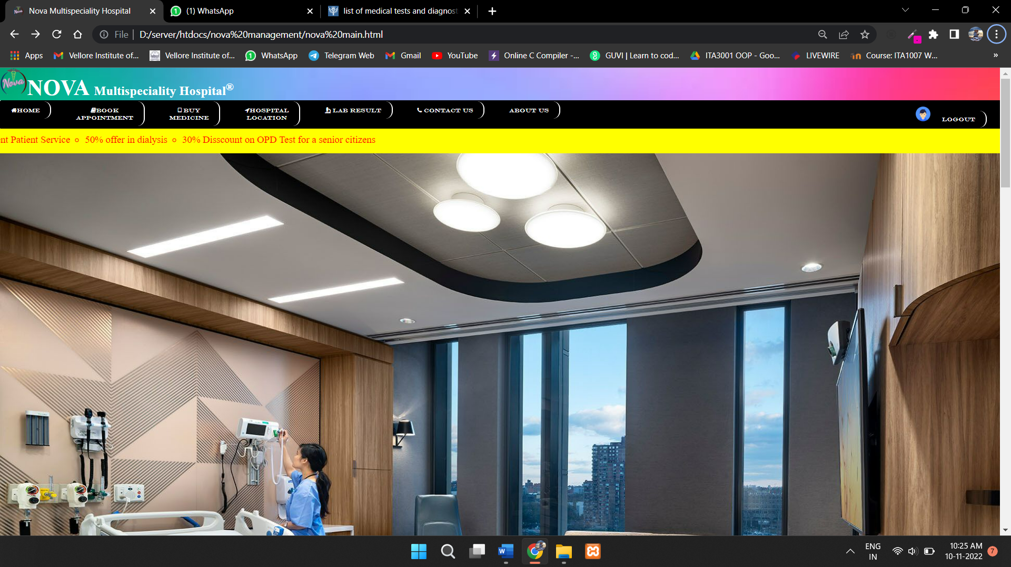

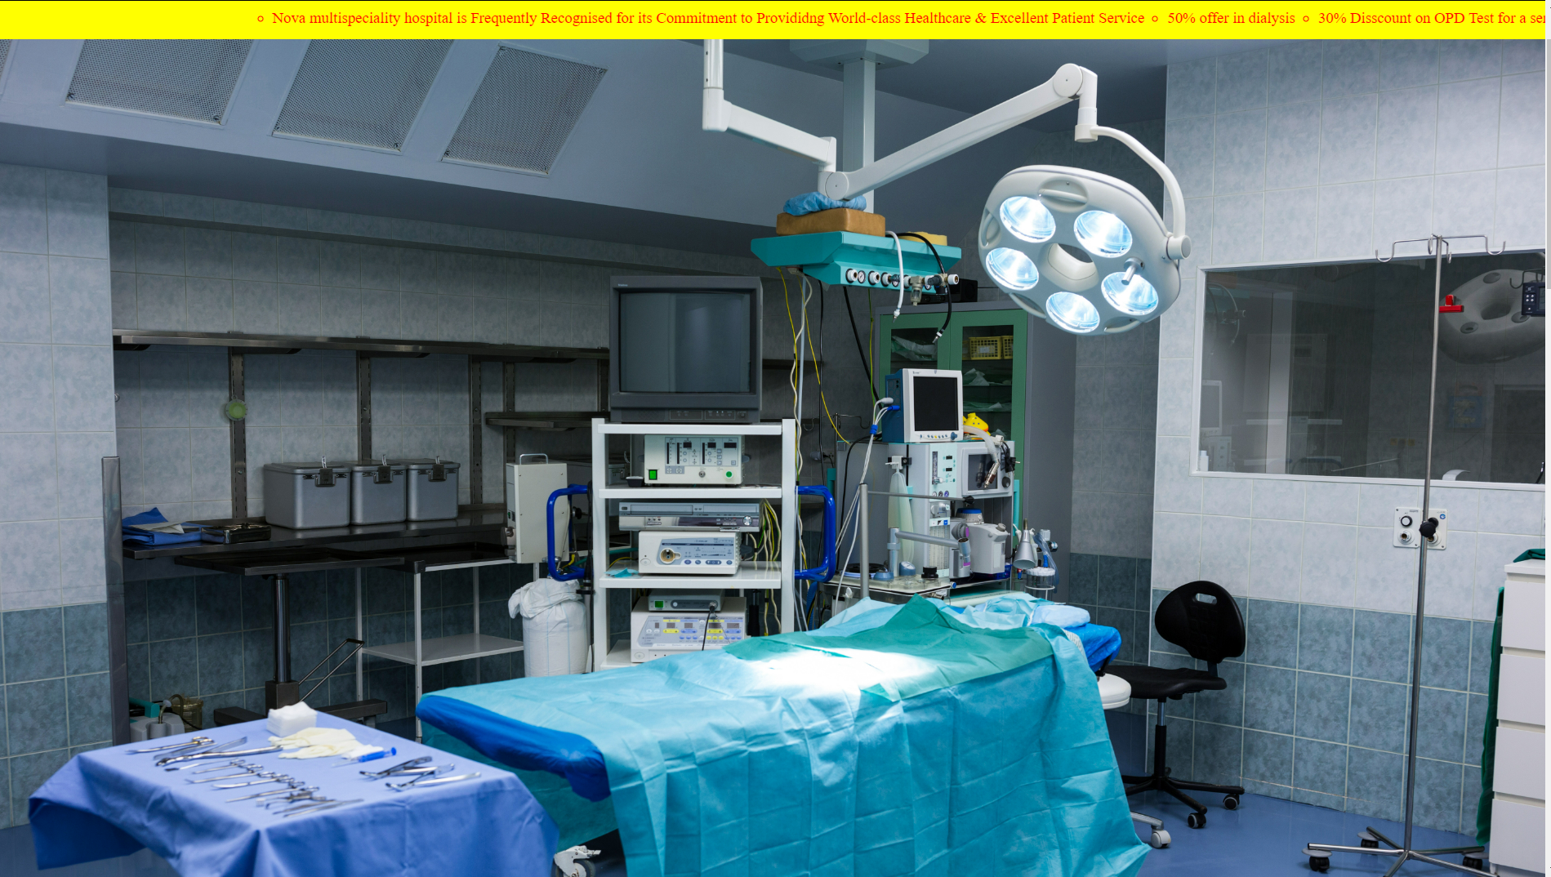

**Doctor list:**

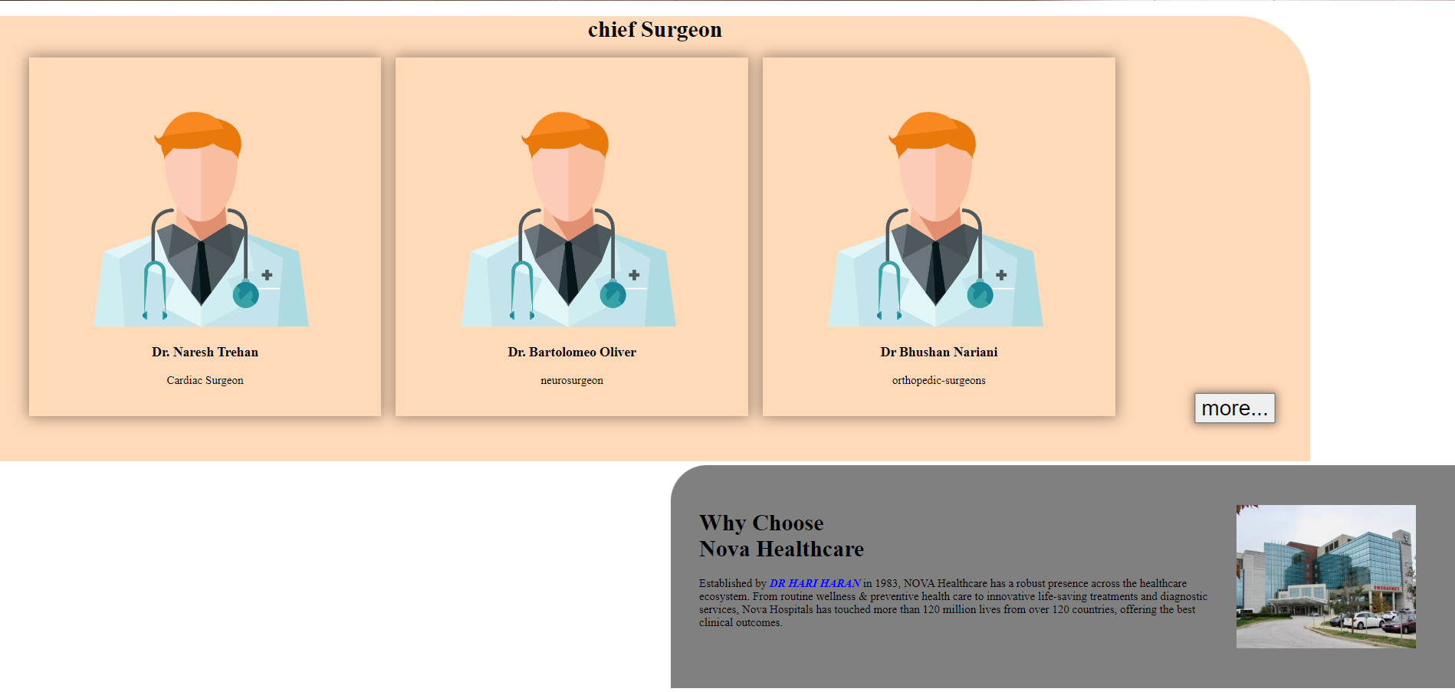 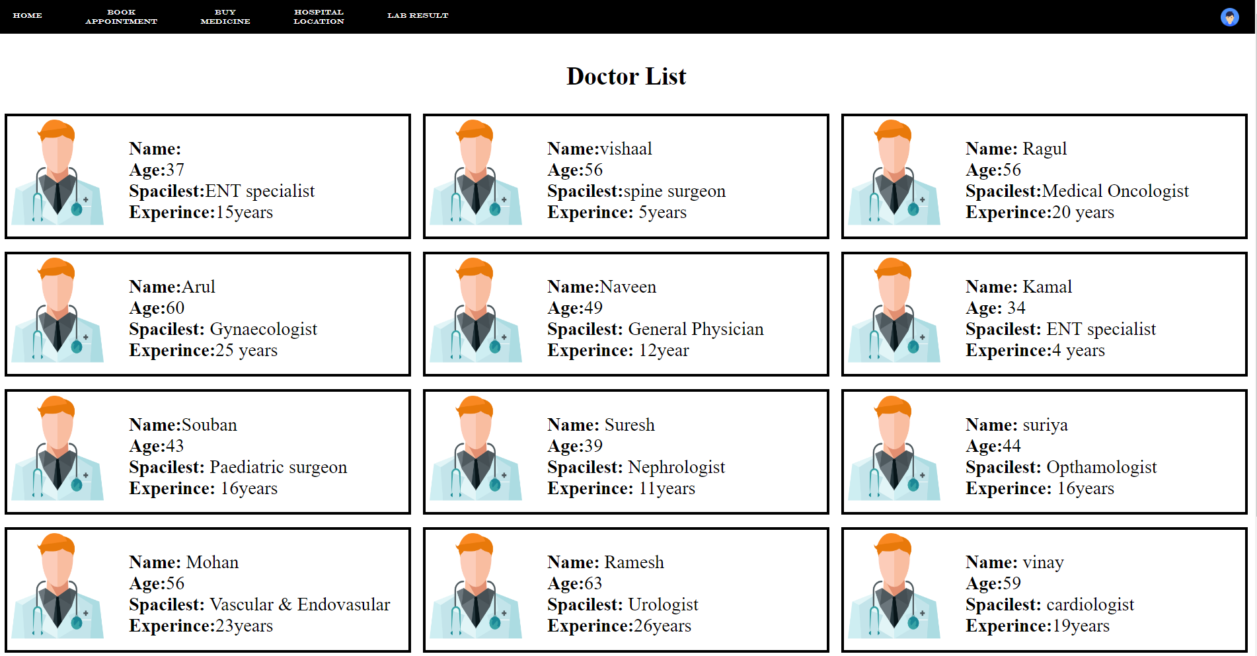 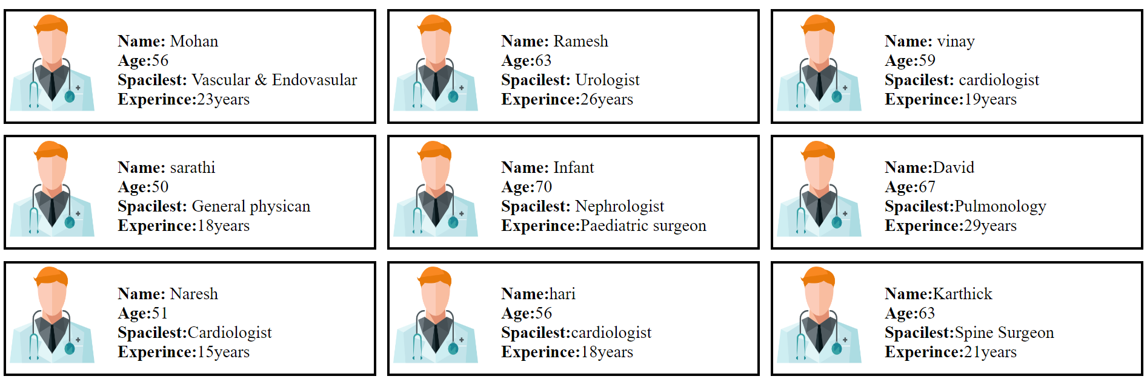

**About us:**

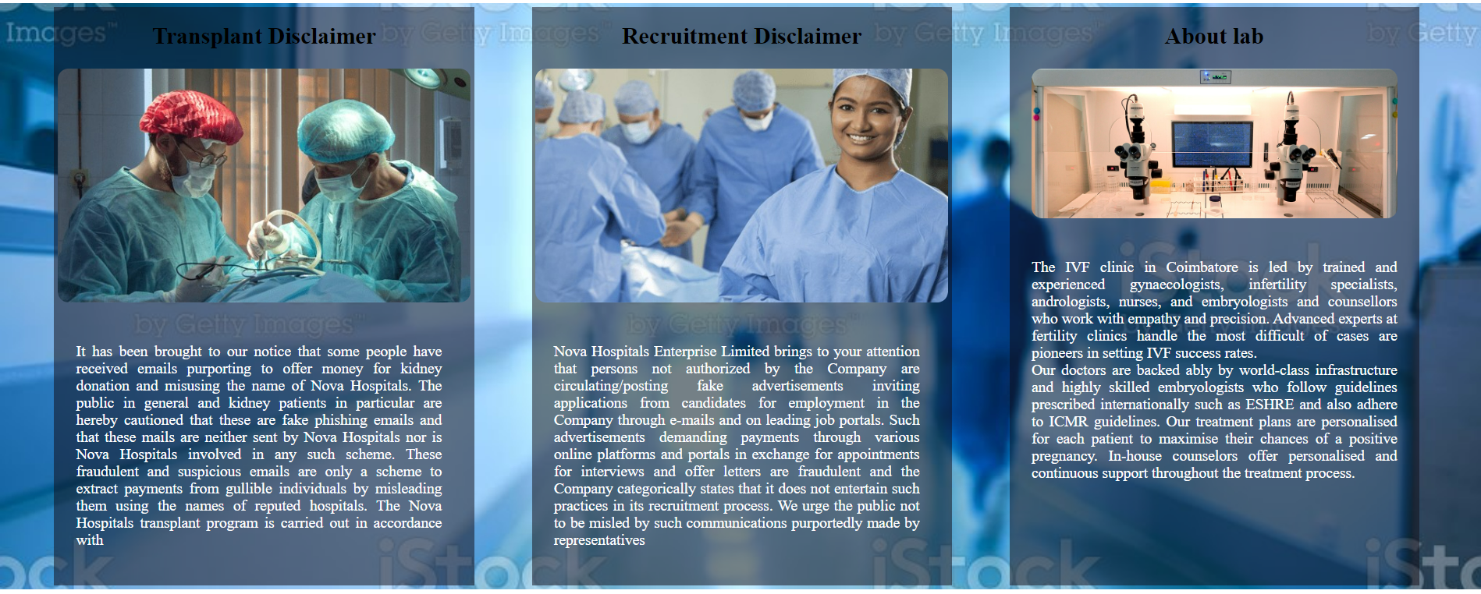

**Footers:**

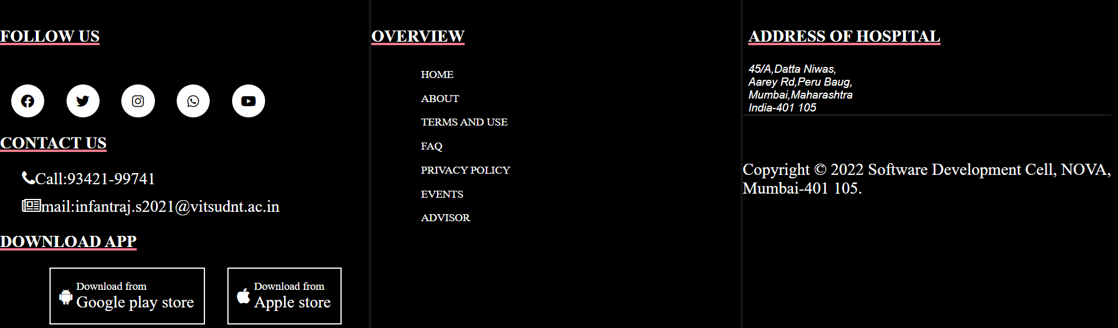

**Login form:**

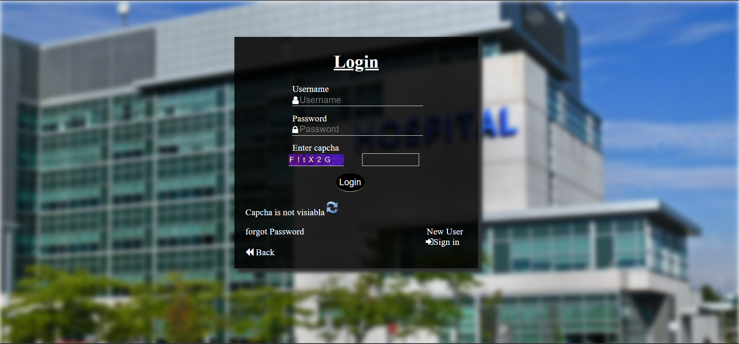

**Sign in:**

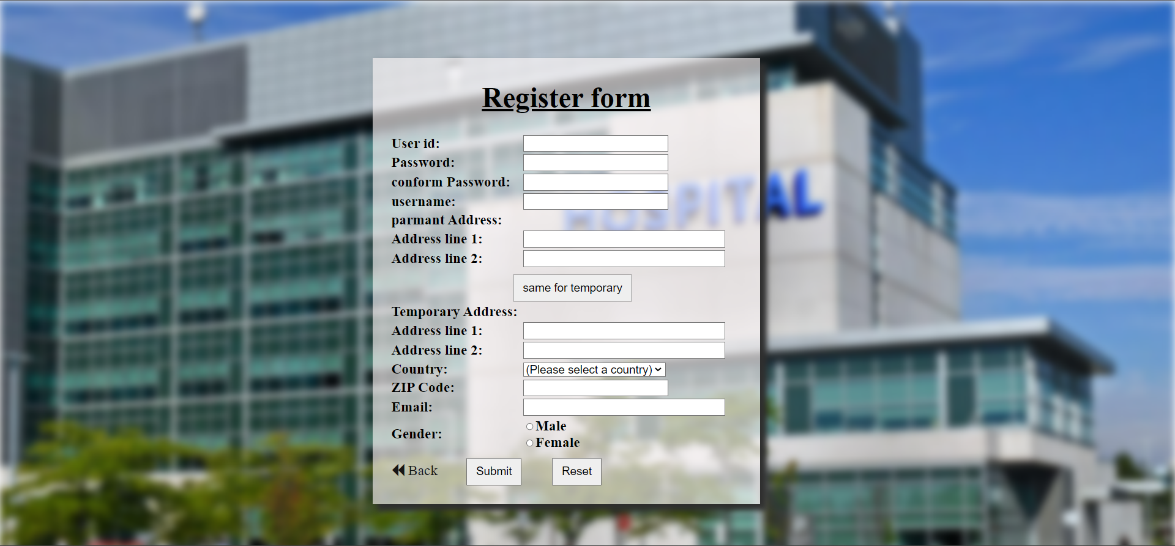

**Forgot password:**

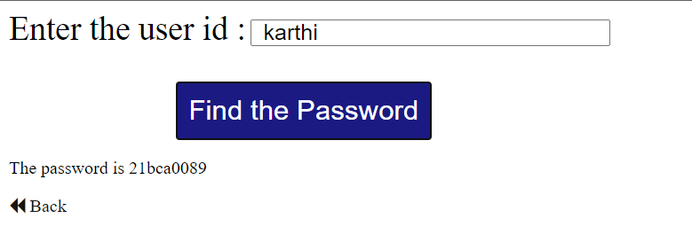

**Booking Appointment:**

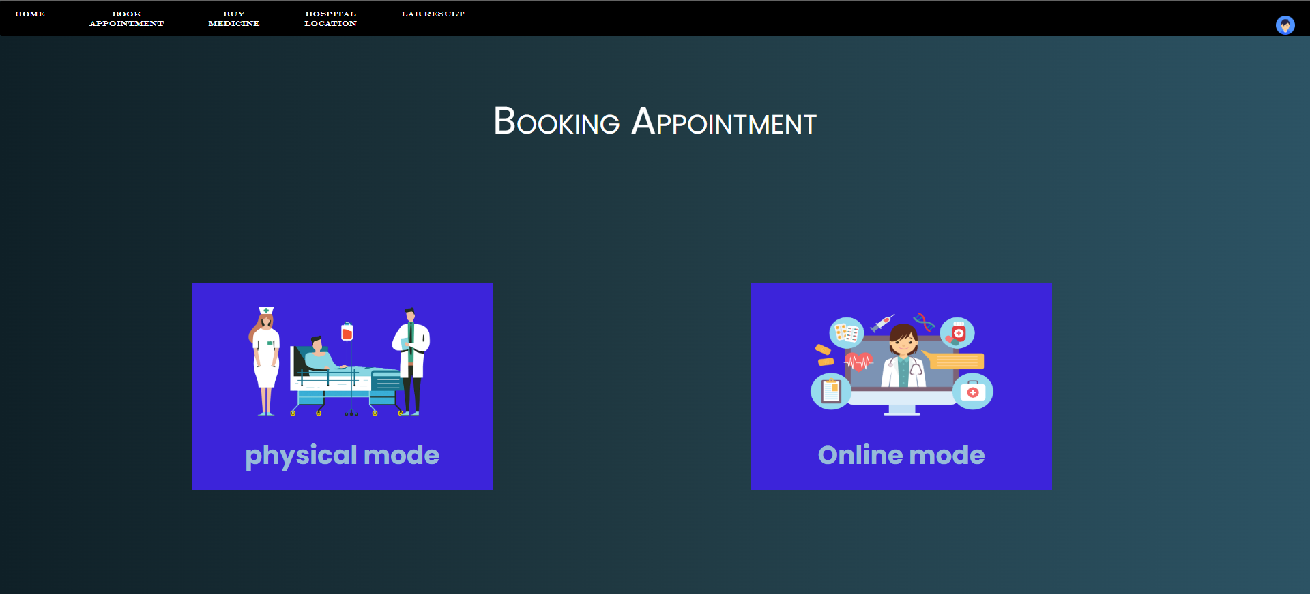

**Physical appointment:**

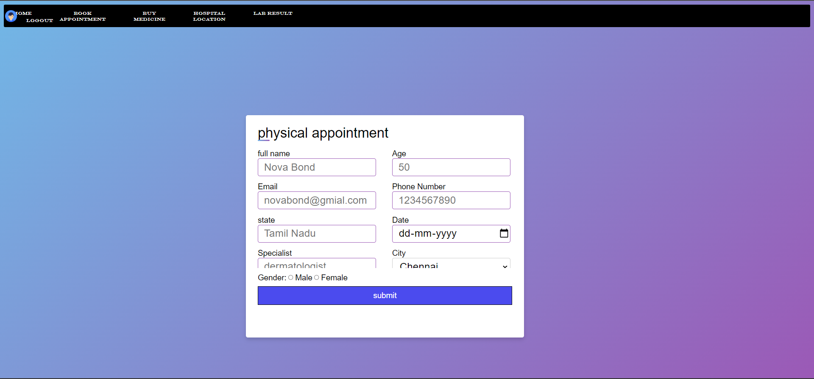

**Online appointment:**

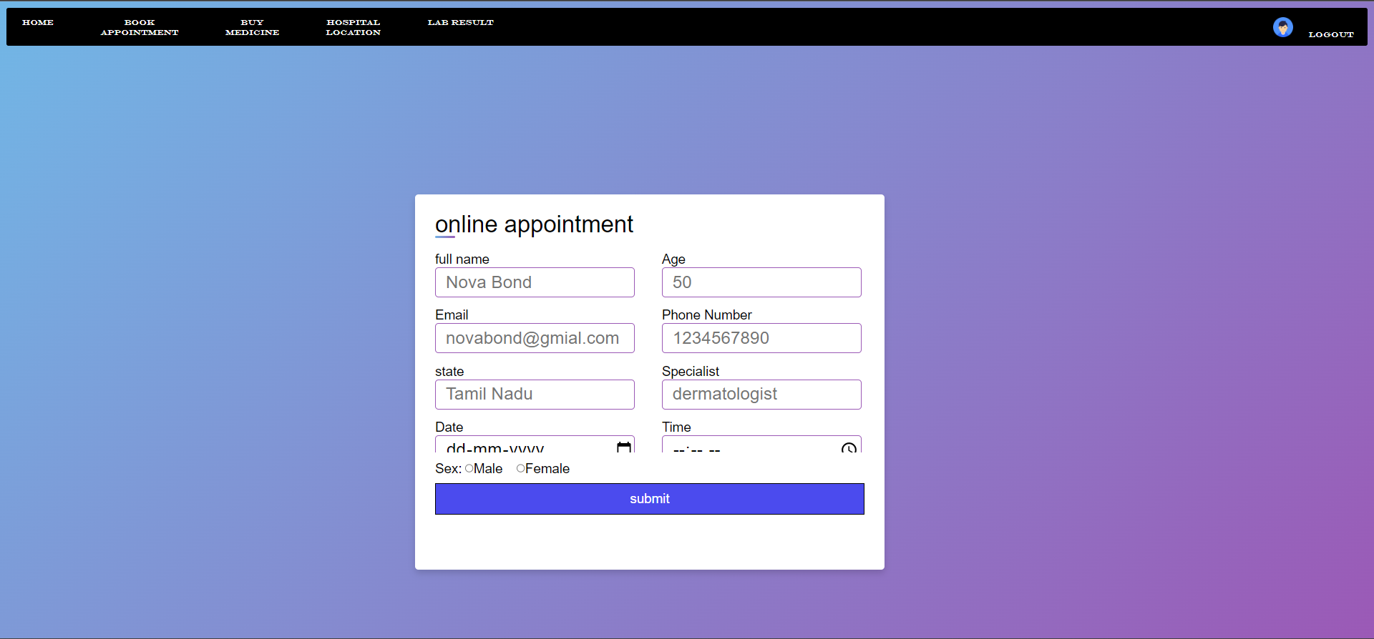

**Without login no page opens:**

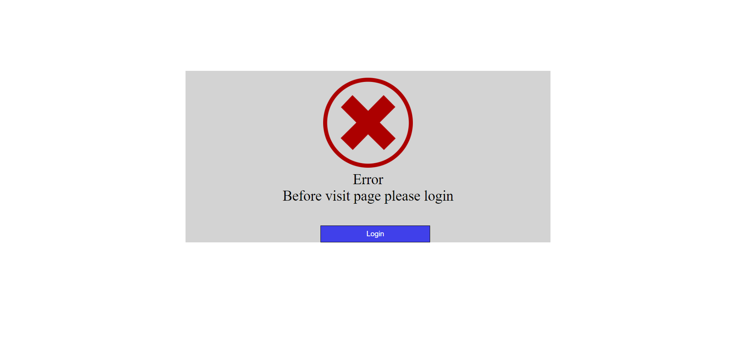

**Pharmacy :**

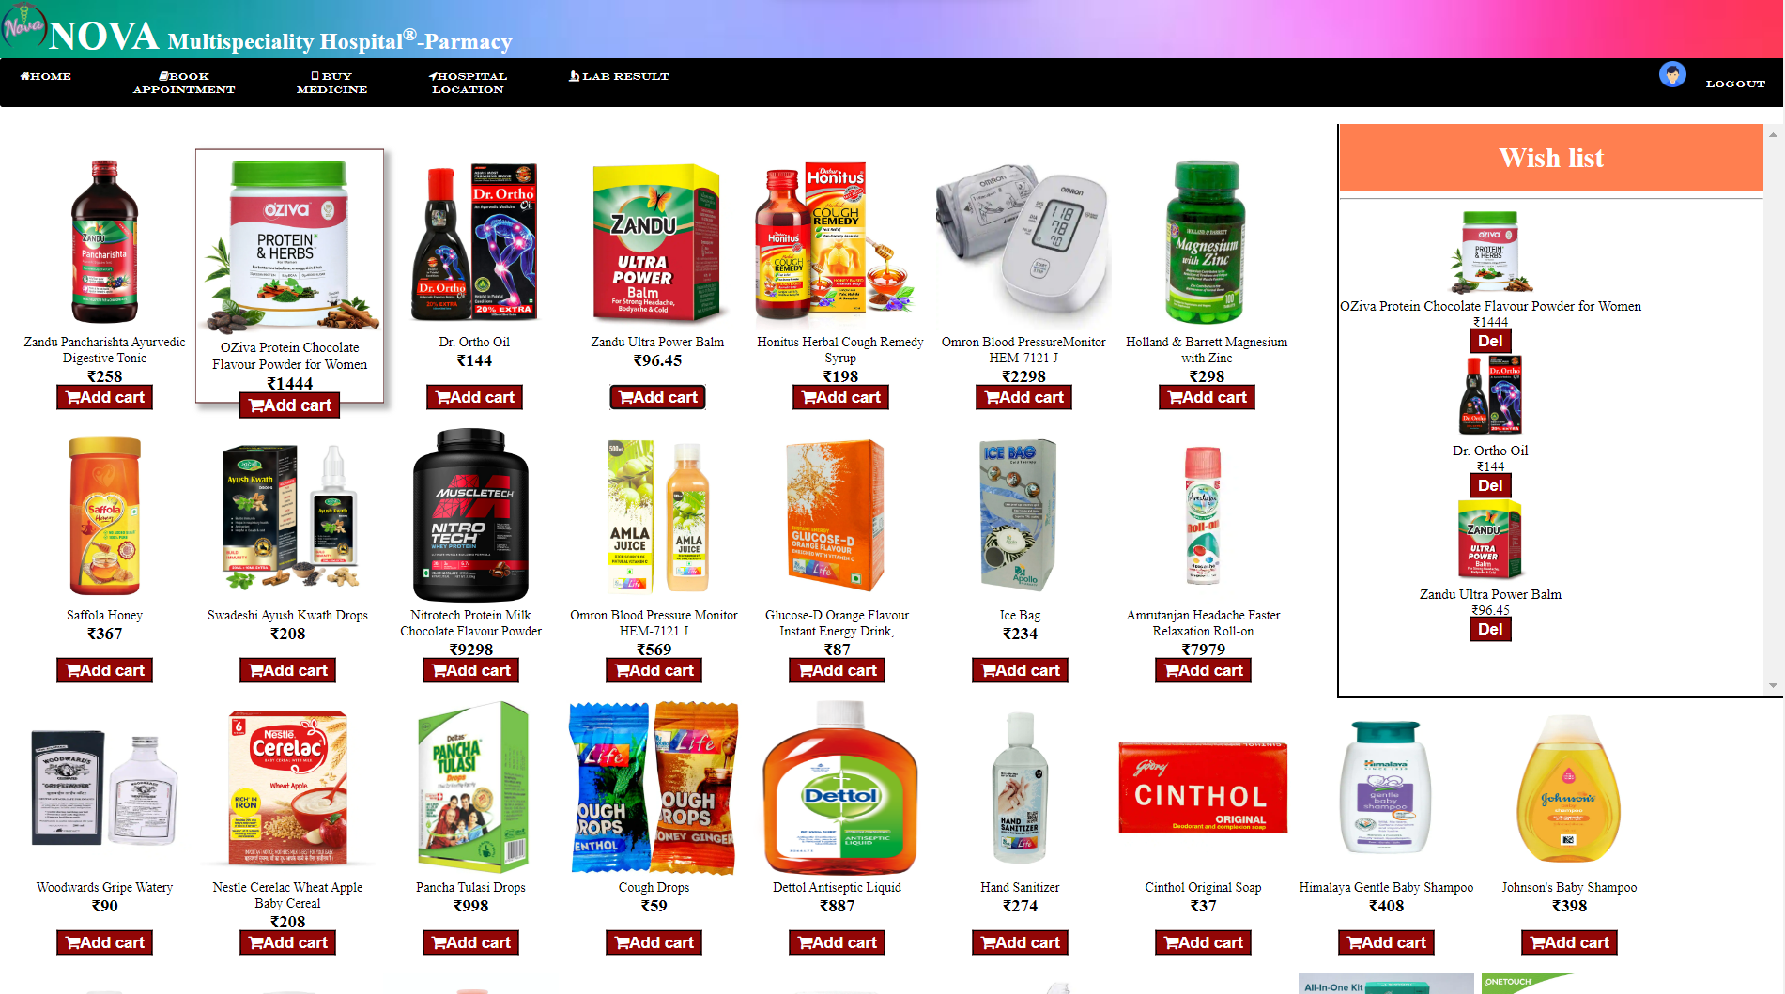

**Lab Main page:**

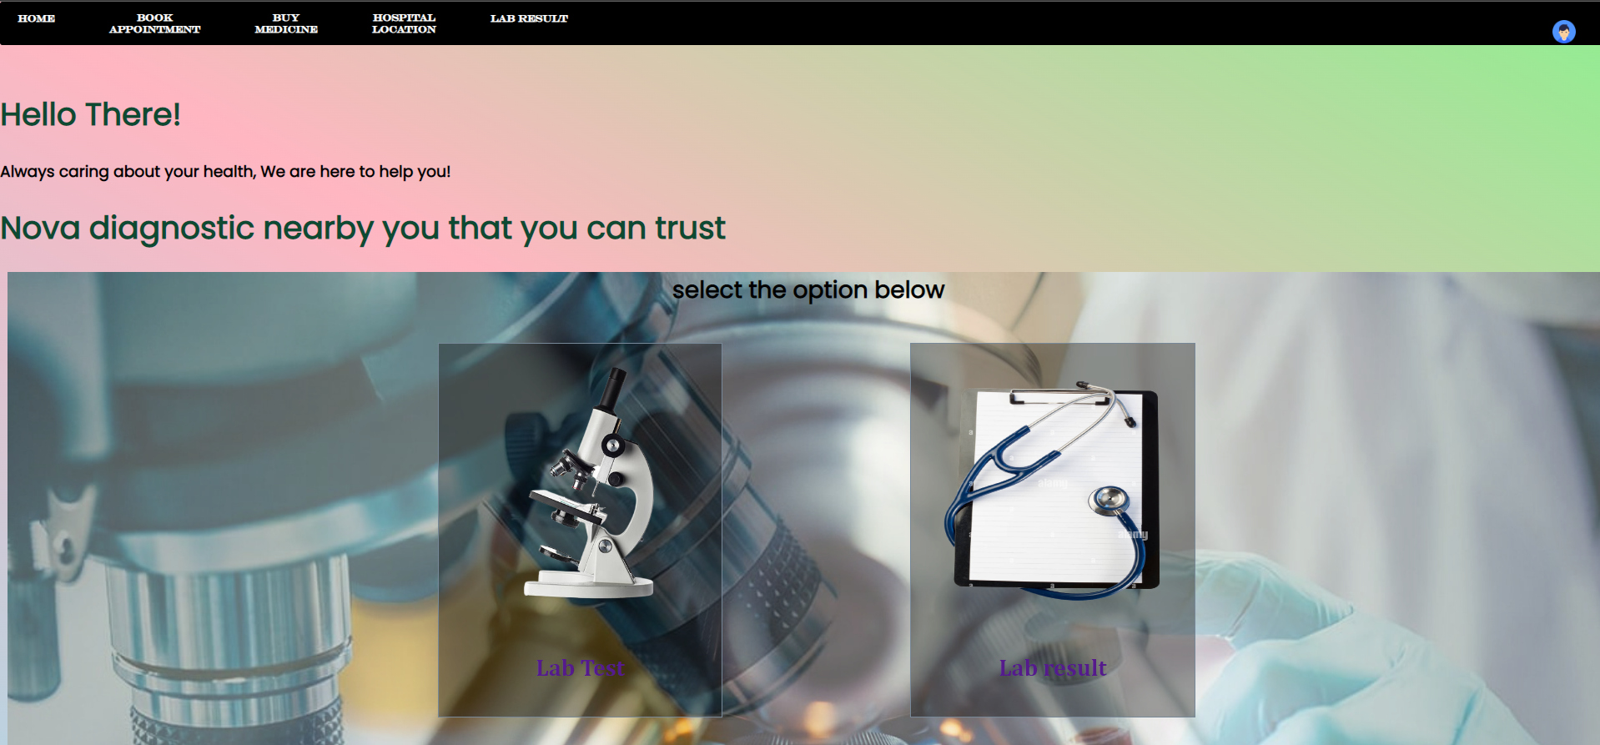

**Lab test Appoinment:**

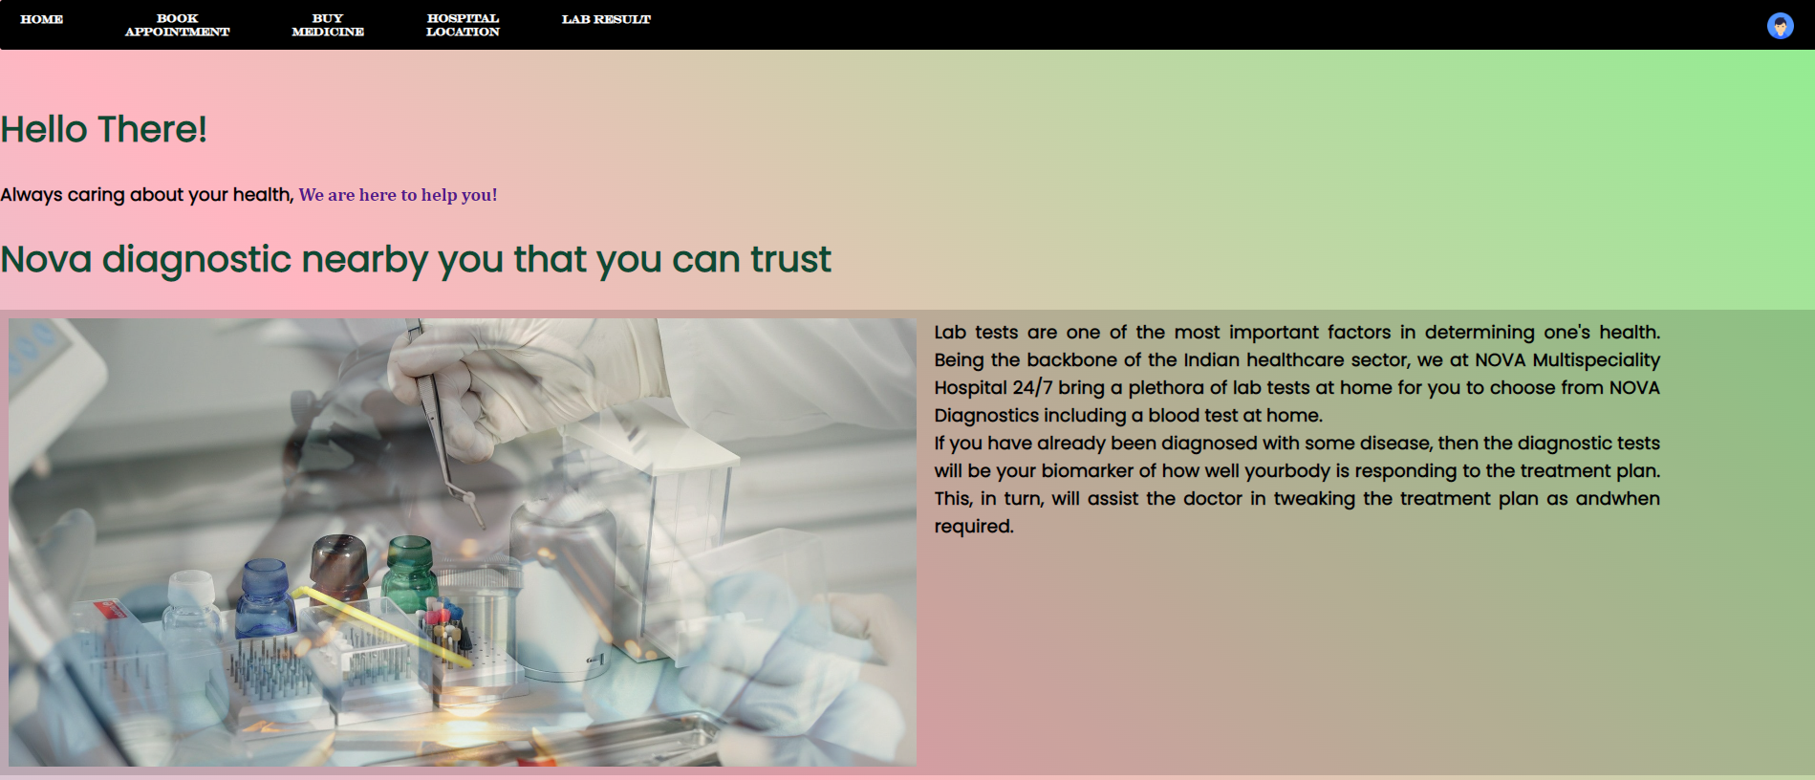

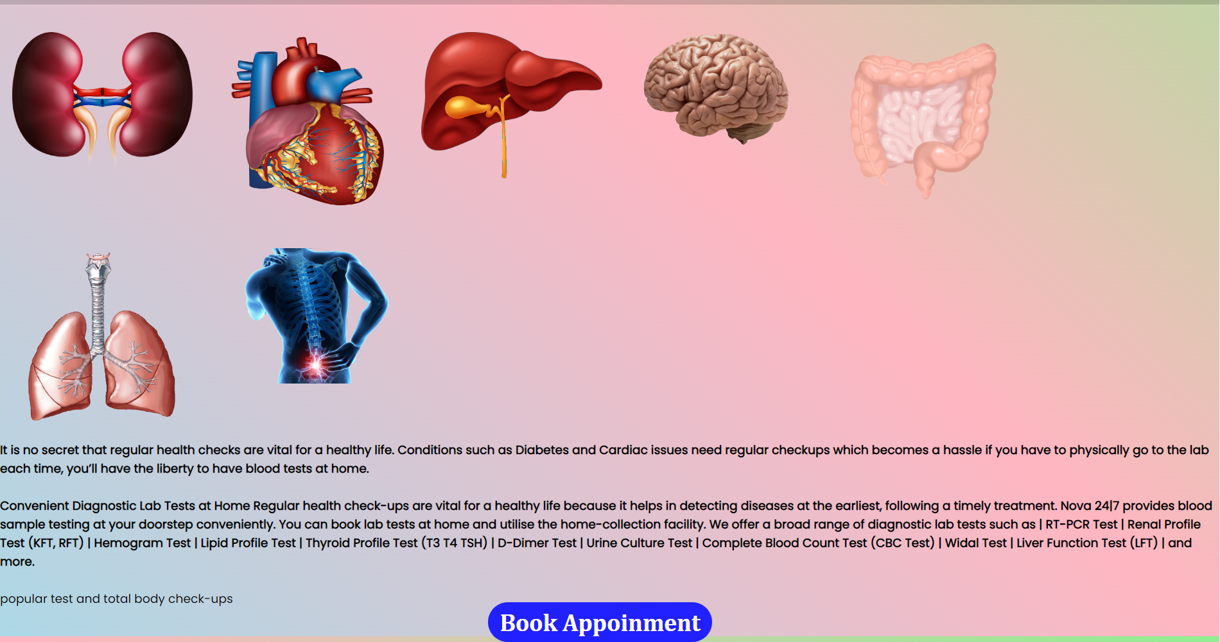

**Lab Result:**

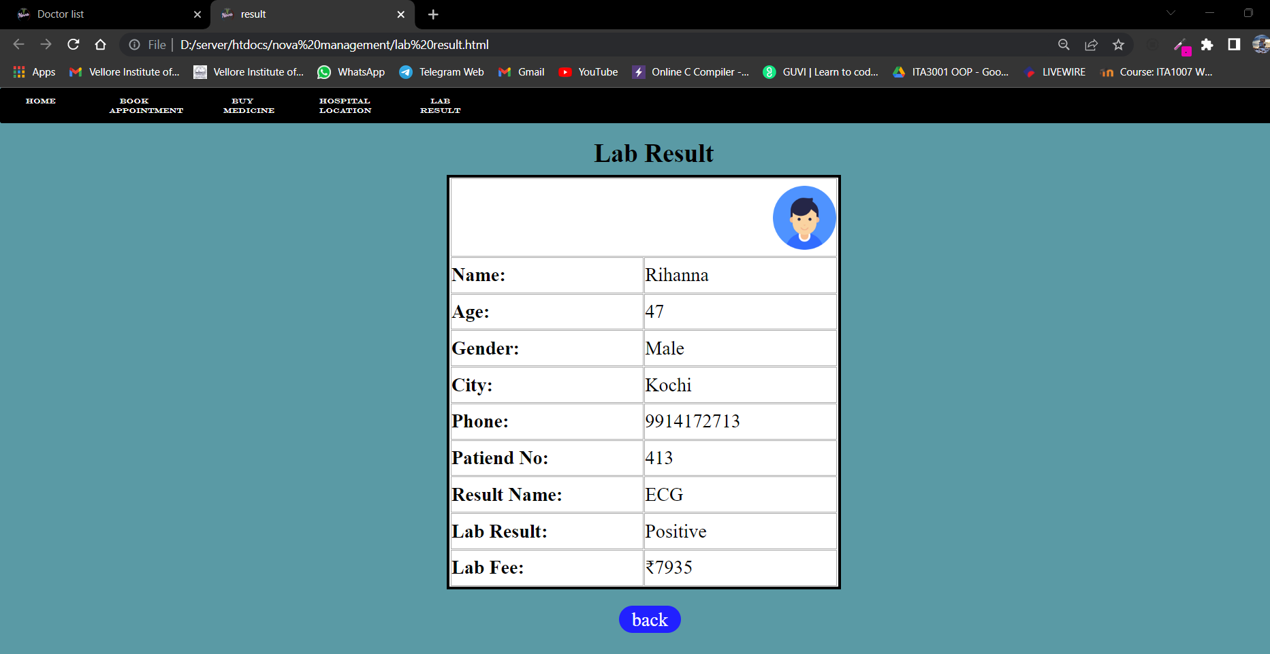

**Cookies**

**Login:**

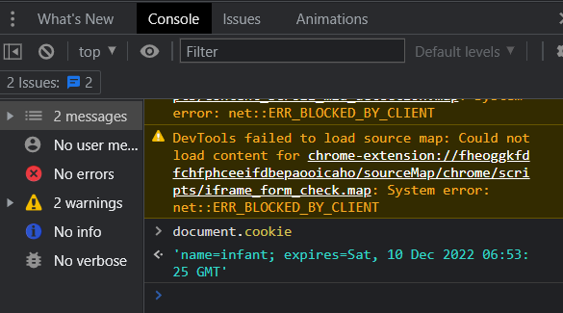

**Physical appointment:**

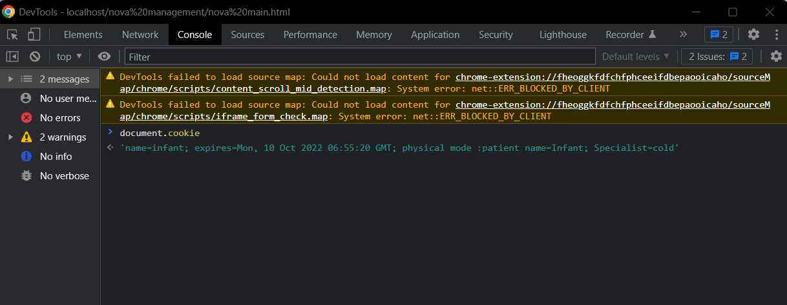

**Online appointment:**

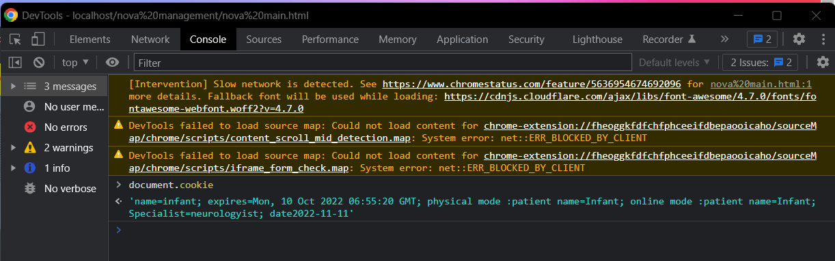

**Xampp :**

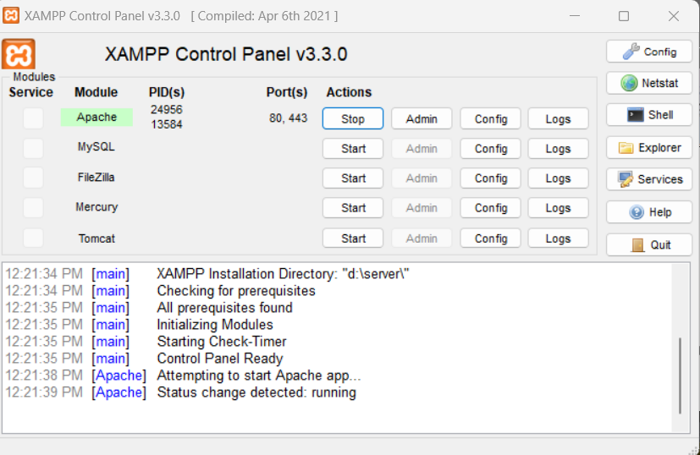

**CONCLUSION AND FUTURE WORK**

By implementing this web based application the website and customized application on the tablet. The management of the patients will be very much easier, efficient and less time consuming. It will be easy for the doctors and patient to access the records and reports as the history and reports are already present in the system ,so the patient will not have to carry all the reports and big x-rays and MRI films etc. The patient details are already present in the database while registration so there is no need to fill a form during emergency cases. The doctors can check details of the patients on their system, provide prescription on a click which will be sent to the pharmacist this will reduce a huge amount of time as the pharmacist knows which medicines to be kept ready before hand, the communications among the doctor and patient is enhanced as the patient can get as much help online. It will help to reduce many manual efforts, time taken and cost.

**Full project:**

<https://drive.google.com/drive/folders/1x6mk4j0DF-MgvBk0bY7KYICeTpclx429?usp=share_link>

**REFERENCES**

[1] Measuring the Quality of Health Care:

[2] APPOLO MULTISPECIALITY HOSPITAL

[3] NARUVI MULTISPECIALITY HOSPITAL

